Attendance Management System
A PROJECT REPORT
Submitted in partial fulfilment of the
requirements for the award of the Degree of
BACHELOR OF SCIENCE (INFORMATION TECHNOLOGY)
By
MOHD SOHEL UMAR SHAIKH
Seat No. :- 3014822
Under the esteemed guidance of
Mr Harishankar Mishra.

DEPARTMENT OF INFORMATION TECHNOLOGY
Navneet College of Arts, Science & Commerce
Mumbai Central, Mumbai – 400008
(Affiliated to University of Mumbai) Maharashtra

PROFORMA FOR THE APPROVAL PROJECT PROPOSAL

PNR NO. : 2023016400344084 SEAT NO. : 3014822

1 Name of the Student : MOHD SOHEL UMAR SHAIKH
2 Title of the Project : Attendance Management System Web Portal
3 Name of the Guide : Mr Harishankar Mishra
4 Teaching Experience of the Guide : 8 Years
5 Is This Your First Submission : YES NO

Signature of the Student Signature of the Guide

Date : ________________ Date :_______________

Signature of the Co-ordinator
Date : ________________

NAVNEET EDUCATION SOCIETY^{’s}
NAVNEET COLLEGE OF ARTS, SCIENCE& COMMERCE

Mumbai Central, Mumbai, Maharashtra 400008
(Affiliated to University of Mumbai)
DEPARTMENT OF INFORMATION TECHNOLOGY


CERTIFICATE

This is to certify that the project entitled “Attendance Management System
Web Portal” is bonafide work of MOHD SOHEL UMAR SHAIKH Seat No. 3014822 has submitted to the University of Mumbai in partial fulfillment of the requirements for the award of the degree of Bachelor of Science in Information Technology.

Supervisor/ Project Guide Coordinator

Internal Examiner ExternalExaminer

College Seal
ABSTRACT
This project report presents the design and development of a comprehensive Attendance Management System, engineered to streamline and automate institutional attendance processes. Responding to the challenges of manual attendance tracking, the web-based system allows teachers to digitally record, manage, and analyze student presence across various subjects and classes. Developed on a secure and scalable stack (Python/Flask and PostgreSQL), the application features role-based authentication, dynamic attendance data validation, and intuitive dashboards for instant analytics. Key modules include secure user logins, a responsive interface for attendance entry, and real-time reporting with export options for administrative use. The report documents the entire project lifecycle, from requirement gathering and robust database design to implementing essential security practices (such as password hashing) for production-readiness. The end result is a functional, reliable, and user-friendly software prototype, ready for deployment in educational settings.

ACKNOWLEDGEMENT
I sincerely thank all who played a vital role in the completion of this project.
I am grateful to the management and Principal of NAVNEET COLLEGE OF ARTS, SCIENCE & COMMERCE for their consistent guidance and infrastructure.
A special note of appreciation is due to my Project Guide, Mr Harishankar Mishra, for sharing invaluable insights, thoughtful critiques, and motivation that shaped my technical approach on this assignment.
Further, my gratitude extends to Mr Satyendra Pal, HOD of I.T., for always being available for support. Lastly,
I owe a special thanks to my family and friends, whose confidence and patience encouraged me at every stage of the project journey.

DECLARATION
I, MOHD SOHEL UMAR SHAIKH, student of B.Sc. IT, Seat No. 3014822, hereby declare that the project entitled"Attendance Management System" is an authentic work done by me under the supervision of Mr. Harishankar Mishra, as a partial fulfillment of the requirements for the B.Sc. IT degree at NAVNEET COLLEGE OF ARTS, SCIENCE & COMMERCE.
I affirm that this project is my original contribution and has not been submitted to any other university or institution for any degree or diploma. All sources, references, software, and tools used have been appropriately acknowledged within the report.

Signature

MOHD SOHEL UMAR SHAIKH
TABLE OF CONTENT
Chapter 1 : Introduction 1
  - Background 1
  - Objectives 1
  - Purpose, Scope, Applicability 2
1.3.1 Purpose 2
1.3.2 Scope 2
1.3.3 Applicability 3
  - Achievement 4
  - Organization of report 4
Chapter 2 : Survey of Technology 5
2.1 Frontend 5
2.2 Backend 6
2.3 Reason for selecting technology 7
Chapter 3 : Requirement Analysis 8
3.1 Problem Definition 8
3.2 Requirement Analysis 8
3.2.1 Function And Requiment 8
3.2.1 Non-Function And Requiment 9
3.3 Planning & Scheduling 9
3.3.1 Gantt Chart 9
3.3.2 Pert Chart 10
3.4 Requirement Specification 11
3.4.1.Technical Requirement 11
3.4.2 Software Requirement 12
3.5 Conceptual Model 13
3.5.1 ER Diagram 13
3.5.2 DFD Diagram 14
3.5.3 Class Diagram 15
Chapter 4 : System Design 18
4.1 Basic Module 18
4.2 Data Design 19
4.2.1 Schema Diagram 20
4.2.2 Data Integrity and Constraints 21
4.3 Procedural Design 22
4.3.1 Activity Diagram 22
4.3.2 Use Case Diagram 24
4.3.3 Sequence Diagram 25
4.3.4 Alogrithm Diagram 27
4.4 Security Issue 27
4.5 Test Cases Diagram 29
4.6 User Interface Design 30
Chapter 5 : Implementation and Testing 36
5.1 Implementation Approaches 36
5.1.1 Implementation Plan 36
5.2 Coding Details and Code Efficiency 38
5.2.1 Code Eficiency 58
5.3 Testing Approaches 60
5.3.1 Unit Testing 61
5.3.2 Integrated Testing 63
5.3.3 Beta Testing 66
5.4 Modification and Improvements 68
5.5 Test Cases 71
Chapter 6 : Result and Discussion 72
6.1 Test Reports 72
6.2 User Documentation 77
Chapter 7 : Conclusion 79
7.1 Conclusion 79
7.1.1 Significance of the System 79
7.2 Limitations of the System 80
7.3 Future Scope of the Project 81
REFERENCES

Chapter 1: INTRODUCTION
  - Background:-
The traditional method of recording student attendance in colleges and universities has long depended on manual registers and paper sheets. This approach is often time-consuming, error-prone, and lacks real-time accessibility for both students and teachers. Manual attendance management makes it difficult to generate accurate summary reports and track trends, resulting in administrative inefficiencies.
With the increasing adoption of digital technologies in education, institutions are recognizing the urgent need to modernize their attendance systems. A web-based attendance management system provides a reliable, automated alternative that streamlines daily operations. Such a system offers secure data storage, easy retrieval, and instant report generation, which benefits students, teachers, and administrators alike. The proposed project, built using Python Flask and PostgreSQL, aims to address the real-world challenges faced in academic record keeping by providing a user-friendly, scalable, and accurate platform for managing attendance data.
This background highlights the transition from outdated manual practices to efficient computerized solutions. By leveraging modern web technologies, the project supports transparency, reduces workload, and enables quick data access for further analytics such as performance analysis and compliance reporting. Ultimately, implementing a digital attendance management system demonstrates the institution’s commitment to academic excellence and operational efficiency.

  - Objective:-
- To automate the daily attendance recording process for students in colleges and universities, replacing manual registers with a web-based solution.
- To enable teachers to mark, review, and update student attendance efficiently through a user-friendly interface.
- To provide administrators with real-time access to attendance reports, summaries, and analytics for all classes, semesters, and subjects.
- To ensure secure and centralized storage of student attendance data for easy retrieval and long-term record maintenance.
- To minimize common errors and duplication of data typically found in manual attendance tracking systems.
- To enable filtering and generation of attendance reports by class, semester, subject, and individual student.
- To support integration with analytics and visualization tools for advanced insights, such as attendance trends and student performance charts.
- To facilitate multi-level access for different user roles (teacher, student, administrator) for discipline and transparency.
- To allow for seamless expansion and future upgrades, such as incorporating subject-wise and semester-wise attendance features.
- To improve operational efficiency for academic institutions, saving time and resources while enhancing data accuracy and reliability.

1.3.1 Purpose:-
- To accurately record and monitor student attendance in a streamlined digital format.
- To enable automation of attendance marking processes for teachers, reducing manual work.
- To provide real-time access to attendance records for students, teachers, and administrators.
- To improve data accuracy by eliminating errors associated with manual attendance tracking.
- To facilitate quick generation of attendance reports and summaries for academic evaluation.
- To enhance transparency and accountability in the attendance management process.
- To support multi-level access control for different roles such as students, teachers, and admin.
- To enable filtering and management of attendance data by class, semester, and subject.
- To integrate attendance data with other academic systems for comprehensive student management.
- To improve operational efficiency and help institutions maintain compliance with academic policies.

1.3.2 Scope:-
- Covers automated attendance marking for students during classrooms or lectures.
- Applicable for academic institutions such as schools, colleges, and universities.
- Enables real-time tracking and monitoring of student attendance data.
- Supports multiple user roles like students, teachers, and administrators with appropriate access.
- Facilitates generation of various attendance reports by class, semester, subject, and student.
- Provides a centralized digital platform for storing and managing attendance records securely.
- Includes functionality for teachers to update, modify, and mark attendance conveniently.
- Ability to send notifications or alerts regarding attendance irregularities (optional extension).
- Scalable design to integrate with other academic or administrative management systems.
- Designed for web-based access supporting desktop and mobile devices for flexible usage.

1.3.3 Applicability:-
- Applicable mainly to educational institutions such as schools, colleges, and universities for student attendance tracking.
- Useful for administration to maintain accurate attendance records for academic auditing and compliance.
- Applicable for teachers and faculty to efficiently mark attendance during classes and lectures.
- Suitable for students to check their attendance history and ensure compliance with attendance policies.
- Can be used in organizations and workplaces to monitor employee attendance and work hours.
- Applicable in government offices and public sector units for biometric attendance and workforce management.
- Useful for organizations with remote or field employees through mobile and web-based attendance marking.
- Applicable for integration with payroll, leave management, and human resource management systems.
- Suited to manage attendance for multiple shifts, departments, and locations in medium to large institutions.
- Applicable for generating attendance reports, notifications, and analytics to support decision-making.

  - Achievement:-
The project successfully achieved the development of a comprehensive Attendance Management System tailored for academic institutions, demonstrating proficiency in Python Flask and PostgreSQL integration. It features secure login mechanisms for both students and teachers, enabling students to access individualized attendance reports, while teachers can mark attendance and generate detailed analytics. The system incorporates a robust backend database design, efficiently managing students’ records, attendance details, subjects, and sessions. Additionally, the project includes the embedding of Power BI dashboards to present real-time attendance analytics and trends, significantly enhancing decision-making and transparency. Through meticulous handling of session management, routing, and database operations, the application offers a seamless user experience, eliminating common issues like duplicate entries and unauthorized access. The interface, built using responsive web technologies, ensures usability across devices. The successful implementation not only automates day-to-day attendance tasks but also delivers insightful reports, positioning the project as an effective solution for attendance monitoring and academic administration.

  - Organization Of Report:-
This report is meticulously structured to deliver a clear, comprehensive, and logically organized understanding of the Attendance Management System project. It commences with an introductory chapter that outlines the project’s background, core objectives, scope, and practical applicability.
Subsequent chapters delve into the systematic analysis of the existing system, followed by a detailed presentation of the design methodology employed. It includes clear explanations of critical components such as user authentication protocols, database schema design, and integration with analytical tools like Power BI for generating insightful attendance reports.
The implementation phase is thoroughly documented, covering step-by-step development activities, module functionalities, and interface designs. The report further discusses the outcomes, highlighting achievements and providing a rigorous evaluation of the system’s performance.
Challenges encountered during development are examined candidly, along with the strategies adopted to overcome them. The concluding sections propose recommendations for future enhancements and potential scalability options, ensuring the system’s continued relevance and adaptability.
The organized flow of this report ensures that readers can seamlessly navigate through the entire lifecycle of the project, gaining a holistic understanding of both technical and practical aspects involved in the development of the Attendance Management System.

Chapter 2: Survery Of Techonologies
JavaScript:-
JavaScript is a widely-used programming language suitable for building attendance management systems due to its flexibility in both frontend and backend development. Its event-driven and asynchronous nature helps handle real-time data updates efficiently. On the frontend, frameworks like React, Angular, or Vue.js create interactive and user-friendly interfaces where students and teachers can mark attendance easily. On the backend, Node.js powers server-side logic such as student registration, attendance tracking, and report generation, connecting seamlessly with databases like MongoDB or MySQL.
JavaScript-based attendance systems validate inputs instantly without page reloads, providing smooth user experience. Secure authentication and role-based access control ensure that admins and teachers access only their authorized data. Real-time dashboards dynamically display attendance summaries and statistics. JavaScript’s rich ecosystem of libraries and frameworks supports scalability and customization, allowing integration with mobile apps or other modules, making it a robust choice for modern educational institutions' attendance management needs.
2.1 Frontend:-
The frontend of the Attendance Management System is developed using a modern and responsive technology stack comprising HTML5, CSS3, and Bootstrap, ensuring an intuitive and visually appealing user interface across all device types.
HTML5 structures the web pages by defining essential elements such as forms, tables, buttons, and navigation menus used for user login, attendance marking, dashboards, and report views.
CSS3 contributes to the styling of these elements, applying consistent colors, fonts, spacing, and responsive layouts. The system leverages custom CSS classes alongside Bootstrap’s powerful grid system, which guarantees alignment, adaptability, and aesthetic uniformity throughout the application.
Bootstrap is integral in enabling the design to be mobile-friendly. It offers readily available UI components and utilities, accelerating development while maintaining professional quality. This ensures the system performs flawlessly on desktops, tablets, and smartphones, providing accessibility and usability in diverse environments.
JavaScript is employed on the client side to enhance interactivity. It facilitates functionalities such as real-time validation of input data to prevent errors during data entry, dynamic filtering and updating of displayed content—for example, showing students based on the selected class, semester, or subject—and smooth navigation that avoids full page reloads, thereby improving responsiveness.
The frontend also incorporates Font Awesome icons, which add visual clarity by symbolizing actions and statuses throughout the UI. Additionally, animated transitions and modals contribute to a polished user experience that feels modern and engaging.
Together, these technologies ensure that both teachers and students can interact effortlessly with the system, allowing for efficient attendance recording, immediate system feedback, and rich visual analytics. The frontend design prioritizes usability and performance, thereby supporting seamless attendance management activities.

2.2 Backend:-
The backend of the Attendance Management System is developed using Python and the Flask web framework, offering a lightweight yet powerful platform for building scalable web applications. Flask efficiently manages all server-side operations including user authentication, session control, and URL routing for pages such as login, attendance marking, and dashboard views.
Requests initiated from the frontend interface are routed to Flask endpoints where logical operations are executed. This encompasses validating user credentials for Students, Teachers, and Admins, retrieving requested attendance records, and updating or inserting attendance data securely in the database.
A key component of the backend is the integration with SQLAlchemy, a robust Object Relational Mapper (ORM) that abstracts database interactions. SQLAlchemy seamlessly translates Python objects into PostgreSQL database entries and vice versa, simplifying database management and enabling complex Create, Read, Update, and Delete (CRUD) operations. This ensures that all attendance and user data remain consistent and accurate throughout the application.
The database design is well structured with core tables such as students for storing student profiles and attendance to maintain daily attendance records linked by student IDs. Additional tables and attributes record related information like class details, semester, subjects, and teacher assignments, enabling advanced filtering and reporting functionality.
Backend validation routines include checks to avoid duplication of attendance entries for the same student on the same date, enhancing data reliability. Moreover, the system supports seamless integration with external reporting tools like Power BI by structuring data efficiently, allowing automated and real-time data visualization through dynamic dashboards.
Overall, the combination of Python, Flask, SQLAlchemy, and PostgreSQL provides a secure, efficient, and scalable backend architecture. It supports real-time data processing, dynamic user interaction, and comprehensive data management essential for effective attendance tracking and institutional reporting.

2.3 Resonal For Selecting The Technology:-
The choice of technologies for this Attendance Management System was driven by their adaptability, ease of use, and performance suited for academic institutions. Python was selected for backend development owing to its simplicity, extensive libraries, and strong community support, which facilitate rapid development and maintenance. Flask framework complements Python by providing a lightweight yet versatile tool to handle web routing, session management, and backend operations without unnecessary complexity. PostgreSQL was chosen as the database due to its reliability, scalability, and powerful querying capabilities, ensuring safe and efficient storage of attendance and student records.
For frontend, HTML5, CSS3, and Bootstrap were used to create responsive and consistent user interfaces that work well across devices like desktops and mobiles. Bootstrap’s ready-made components speed up design and improve user experience through mobile-first responsive layouts. Integration of Power BI was motivated by its powerful data visualization and analytics features, allowing real-time, interactive attendance reports for administrators and faculty. This technology stack collectively provides a well-balanced solution that is secure, scalable, maintainable, and user-friendly, meeting both current and future needs of the institution’s attendance management.

Chapter 3: Requiement And Analysis
3.1 Problem And Definition :-
Problem Statement
In most educational institutions, attendance is recorded manually using paper registers or spreadsheets. This traditional method is time-consuming and prone to errors, such as incorrect entries, loss of data, and difficulty in managing attendance for large classes. Teachers spend considerable time taking attendance every day, reducing teaching time and efficiency. Furthermore, manual attendance management systems lack real-time data availability and make tracking student absence trends cumbersome.
In addition, documenting and maintaining attendance records for long periods, ensuring accuracy, and generating reports for administration or parents requires extra effort and resources. This can lead to delays in identifying students with poor attendance and affect the institution’s ability to maintain discipline and academic standards.
Definition of the Problem
The primary goal is to automate the process of attendance management, providing a system that records, stores, and processes attendance data efficiently. The system should enable teachers to quickly mark attendance electronically, eliminating manual entry errors and saving time. It should also provide students and administrators access to real-time attendance data and comprehensive reports.
The system must handle multiple courses, classes, semesters, and subjects while ensuring the confidentiality and security of attendance information. It should be scalable enough to manage a growing number of students and adaptable for different academic structures and policies.
3.2 Requirement and Analysis
3.2.1 Function And Requirement:-
- User Authentication: The system enables secure login for users including students, teachers, and administrators using unique credentials to protect access to sensitive information and functionalities.
- Mark Attendance: Teachers are empowered to record attendance by selecting the relevant class, semester, and subject, ensuring precise tracking of student presence.
- Attendance Records Management: The system maintains comprehensive attendance data, including date, attendance status (present or absent), detailed student information, and associated subject details.
- View Attendance: Students have access to their personal attendance history and attendance percentage, presented clearly through an intuitive dashboard interface.
- Attendance Reports: Teachers and administrators can generate detailed reports filtered by class, subject, semester, and date range to aid academic monitoring and decision-making.
- Attendance Validation: The system incorporates checks to prevent duplicate attendance marking for the same student on the same date, thereby preserving data accuracy.
- Notification Alerts: Automated alerts are issued to relevant stakeholders if attendance falls below predefined thresholds, encouraging timely interventions.
- Data Export: Attendance data and reports can be exported to common formats such as Excel or PDF, enabling offline access and record-keeping.
- Role-Based Access Control: The system enforces differentiated access rights, ensuring students, teachers, and administrators can only engage with features appropriate to their roles.
- Dashboard Analytics: Summarized statistics and visual charts provide quick insights into attendance patterns, enhancing data comprehension and supporting institutional oversight.

3.2.2 Non-Function And Requirement:-
- Performance: The system should be responsive with minimal latency during attendance marking and report generation.
- Security: User data including attendance records should be protected using encryption and authentication mechanisms.
- Reliability: Ensure accurate data recording and availability without data loss.
- Scalability: Should support increasing number of users, classes, and subjects without performance degradation.
- Usability: Interface should be user-friendly and intuitive, supporting multiple devices and browsers.
- Maintainability: Code and database structure should be well organized for easy maintenance and future upgrades.
- Backup and Recovery: Mechanisms for regular backups and recovery options in case of data failure.

3.3 Planning And Scheduling
3.3.1 Gantt Chart:-
A Gantt Chart is a pivotal project management tool that visually depicts the timeline of a project by displaying tasks as horizontal bars across a calendar. It enables project managers to plan, schedule, and monitor project activities, offering a clear representation of task durations, sequencing, and dependencies. By integrating task names, start dates, durations, and progress, the chart facilitates effective resource allocation and deadline adherence. The chart’s dual components include a task list and a timeline, making it intuitive to track the status of each activity and pinpoint potential bottlenecks.
In the context of software development, including systems like the Attendance Management System, the Gantt Chart provides a structured overview, breaking the project into manageable phases such as planning, design, development, testing, and deployment. This visualization supports stakeholders in understanding workflow relationships, adjusting timelines dynamically, and ensuring timely project delivery. Its ability to illustrate critical paths, milestones, and resource commitments makes it indispensable for both traditional and agile project methodologies.
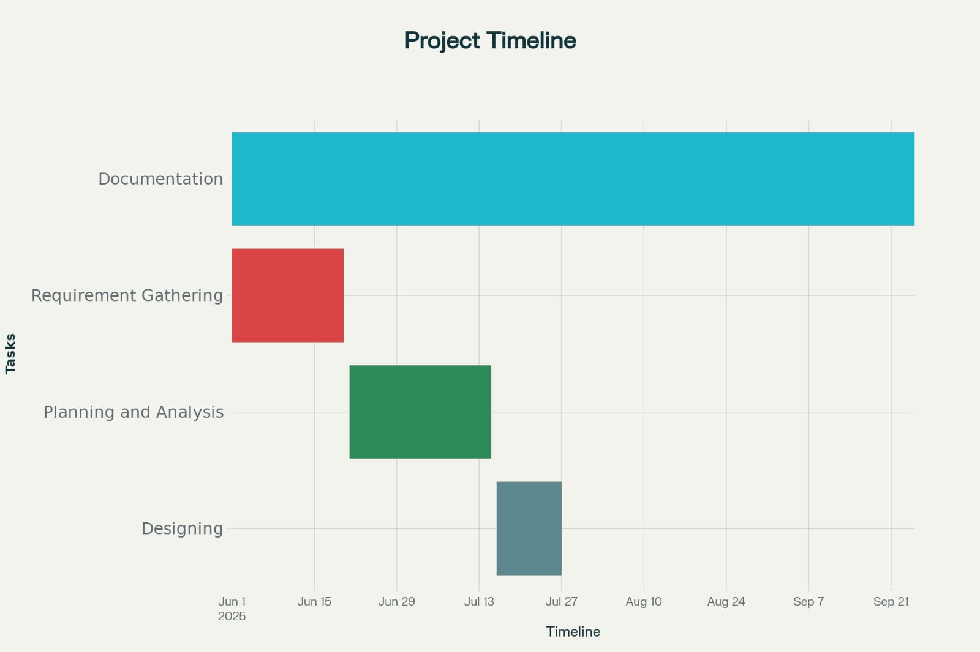

3.3.2 Pert Chart:-
A PERT (Program Evaluation Review Technique) chart is a project management tool used to schedule, organize, and coordinate tasks within a project. It provides a graphical representation of a project’s timeline by illustrating task sequences, dependencies, and critical paths. PERT charts help estimate the minimum time needed to complete the project, identify redundant activities, and allocate resources efficiently to meet deadlines.
For the Attendance Management System project, the PERT chart visualizes project phases such as Definition, Introduction, Chart Creation, Requirement Gathering, Requirement Analysis, Design, and Documentation. Each task is connected to its dependent tasks, showing the flow of activities from start to finish. This helps project managers understand task completion sequences, assess potential bottlenecks, and optimize the schedule to ensure timely delivery of the system.
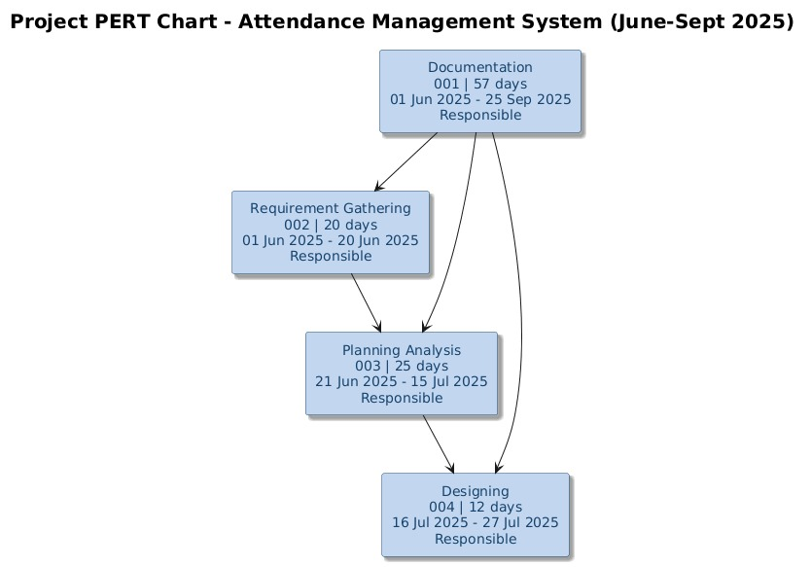
3.4 Requirement Specification
3.4.1.Technical Requirement:-
The technical requirements define the essential hardware, software, and system resources necessary for the successful development, deployment, and operation of the Attendance Management System.
Hardware Requirements
Client Devices: Users access the system via client machines, which may include desktop computers, laptops, or mobile devices. These devices should have reliable internet connectivity to interact seamlessly with the web-based application.
Server Infrastructure: A dependable web server environment is required to host the backend application and database. The server must possess sufficient processing power, memory, and storage capacity to handle concurrent user requests, data processing, and storage needs efficiently.
Networking: A stable and secure network connection is vital to ensure uninterrupted data transmission between client devices and the server. This supports real-time attendance recording, data synchronization, and rapid response times.
3.4.2 Software Requirement:-
The software requirements for the Attendance Management System define the development environments, platforms, tools, and frameworks essential for building and deploying the application effectively:
- Operating System:
Compatible with Windows, Linux, or macOS for development and deployment servers. Client devices can access the system via any modern operating system.
- Backend Framework:
Python with the Flask web framework, providing the structure for building the server-side logic, handling HTTP requests, and managing APIs.
- Frontend Technologies:
HTML5, CSS3, JavaScript, and Bootstrap to create responsive, user-friendly web interfaces accessible on desktops and mobile devices.
- Database Management System:
PostgreSQL for storing and managing attendance records, student profiles, subjects, and related data securely and efficiently.
- Web Server Software:
Apache or Nginx for hosting the web application and forwarding client requests to the backend.
- Development Tools:
IDEs like Visual Studio Code or PyCharm for coding. Version control systems such as Git to manage source code changes and collaboration.
- Reporting and Visualization:
Integration with Power BI or similar BI tools to provide interactive dashboards, reports, and analytics.
- Security Tools:
SSL/TLS certificates to enable HTTPS for secure data transmission. User authentication libraries or modules to enforce login security and session management.

3.5 Conception Model
3.5.1 ER Diagram:-
An Entity-Relationship (ER) Diagram visually represents the structured data model of the Attendance Management System by illustrating the system’s core entities, their attributes, and the relationships between them. This diagram functions as a crucial blueprint for the database design phase, guiding the logical organization of data storage. Key entities typically include Students, Teachers, Attendance Records, Subjects, and Classes, each with defined attributes such as IDs, names, dates, and statuses.
The ER Diagram clarifies how these entities interact, for example, mapping many-to-many relationships between students and subjects, or one-to-many relationships from teachers to classes. This model facilitates the enforcement of data integrity through the use of primary and foreign keys, ensuring consistent and reliable data management. By providing a clear visualization of the data flow and associations, the ER Diagram assists developers and stakeholders in understanding system requirements, streamlining database implementation, and supporting future scalability or modifications.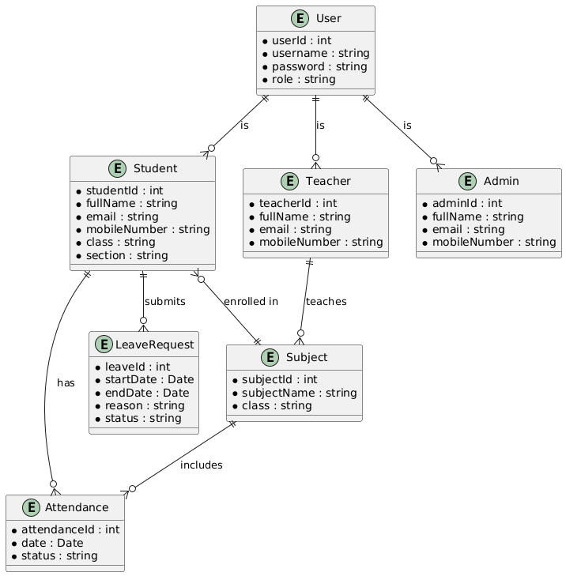

3.5.2 DFD Data Flow Diagram:-
The Data Flow Diagram (DFD) for the Attendance Management System provides a clear graphical representation of how data moves and is processed within the system. It highlights the interactions between the primary users—students, teachers, and administrators—and the system’s core functional modules such as user authentication, attendance marking, and report generation.
The diagram illustrates how student and teacher inputs flow through various processes, showing validation and processing steps that ultimately lead to updating or retrieving data from key data stores like student profiles and attendance records. By depicting data flows to and from these stores, the DFD clarifies the system’s operation in terms of inputs, processes, storage, and outputs.
This visualization is crucial for understanding system behavior, ensuring efficient and secure data handling. It assists developers and stakeholders in verifying that all necessary data pathways have been considered, facilitating smooth execution of attendance management tasks while maintaining data integrity and privacy.
Agar aap chahte hain, toh ismein aur technical details ya diagram ke levels (context level, level 1, etc.) bhi add kar sakta hoon.
Related
Is DFD ka level-0 aur level-1 ka tafseeli bayaan likh do
Har process ke liye inputs, outputs aur data stores list karo
External entities aur unke interactions ko Urdu mein wazeh karo
Security aur validation ke liye required checks aur flows batao
Is DFD ko diagram mein banane ka step-by-step tariqa samjhao

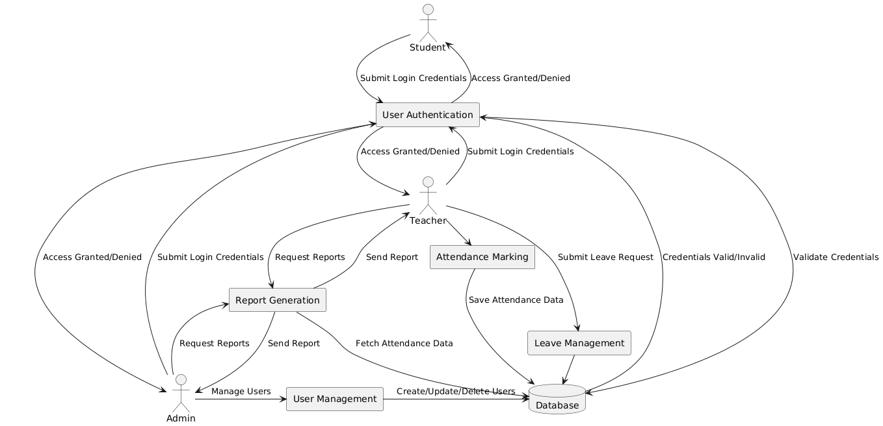

3.5.3 Class Diagram:-
The Class Diagram of the Attendance Management System provides a visual representation of the key system components by illustrating the primary classes such as Student, Teacher, Admin, Subject, and Attendance. Each class is defined with its significant attributes and methods that encapsulate the behavior and data pertaining to that entity.
This diagram highlights the relationships and associations between the classes, such as how a Student is linked to Attendance records, or how Teachers are associated with Subjects. It effectively models inheritance, composition, and dependencies which clarify how an object of one class interacts with another within the system.
By depicting the static structure and organization of system elements, the Class Diagram serves as a crucial blueprint for developers. It supports efficient coding by clarifying class responsibilities, promotes easier maintenance through clear modularization, and provides a foundation for future scalability by anticipating extensions or modifications.
Overall, the Class Diagram is a vital tool in understanding the architecture of the Attendance Management System, ensuring coherent design and systematic implementation.
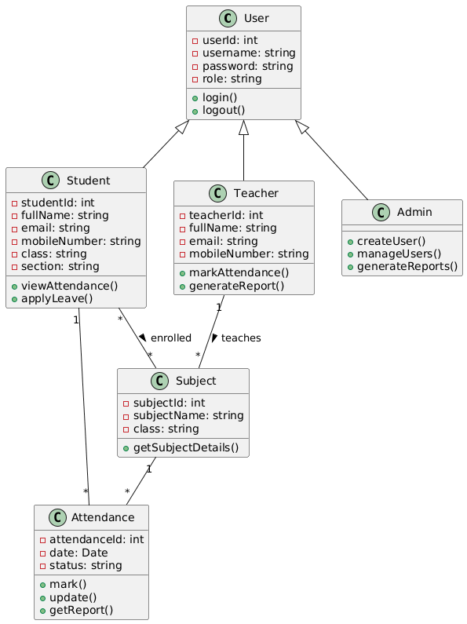

Chapter 4: System Design
4.1 Basic Modules:-
- User Management Module:
This module manages the creation and authentication of user accounts including students, teachers, and administrators. It assigns roles and controls access to various system features based on these roles, ensuring that users have the correct permissions and profile settings for their needs.
- Student Management Module:
This module maintains comprehensive student information—such as personal details, enrollment data, class assignments, and contact info. It supports efficient management of student data, allowing batch imports and updates to streamline administrative tasks.
- Teacher Management Module:
This module keeps records of teachers, their profiles, and subject allocations. It enables management to assign teachers to specific courses and classes and grants teachers access to mark attendance and generate reports for their assigned subjects.
- Class and Course Management Module:
Responsible for defining all classes and courses offered by the institution. It allows administrators to create, edit, or delete course details, assign courses to classes, and manage the relationships between classes, courses, and teachers.
- Attendance Management Module:
The core component that facilitates marking student attendance for different classes and subjects. It validates attendance entries to prevent errors and duplicates and stores attendance records in the database for future reference and reporting.
- Leave Management Module:
This module tracks student leave requests, allowing students to apply for leaves digitally. Teachers and administrators can review, approve, or reject these requests, integrating leave data seamlessly with attendance records.
- Reporting and Statistics Module:
Generates various attendance reports and visual dashboards. It provides insights on attendance patterns, monthly summaries, defaulter lists, and detailed analytics, enabling educators and administrators to monitor and improve attendance management.
- System Configuration Module:
Allows customization of system settings including attendance policies (like grace periods, half-days), notification preferences, access controls, and other operational parameters to adapt the system to the institution’s requirements.

4.2 Data Design:-
The Data Design phase is critical in structuring and organizing all data components necessary for the efficient operation of the Attendance Management System. This phase ensures that data storage, retrieval, and manipulation are optimized for reliability and scalability. The system is based on a relational database model that incorporates several key entities central to attendance management.
Student Entity: This entity stores essential personal information about each student, including student ID, full name, contact details, class enrollment information, and other relevant demographics necessary for identification and record-keeping.
Teacher Entity: It maintains records of teachers, capturing their unique IDs, names, contact data, and the subjects or courses they are assigned to, facilitating effective classroom and attendance management.
Course and Subject Entities: These define the academic offerings, detailing course names, subject listings per course, and their allocation to various teachers, ensuring well-organized curriculum mapping.
Attendance Record Entity: This crucial entity logs attendance details with attributes such as a unique attendance ID, corresponding student ID, date of attendance, status indicator (present or absent), and the subject related to each attendance record.
Leave Request Entity: This handles the requests for leaves made by students, including start and end dates, the justification for the leave, and the current approval status, enabling systematic leave management.
User Account Entity: Managing the access credentials of all users including students, teachers, and administrative staff, this entity governs authentication, role assignments, and permission controls within the system.
This structured data design fosters coherent and maintainable database architecture, facilitating seamless information flow and robust data integrity throughout the attendance system’s lifecycle. It forms the backbone of all application functionalities by ensuring that data relationships and constraints are properly maintained.

4.2.1 Schema Design:-
The Schema Design provides a detailed blueprint of the database structure that supports the Attendance Management System. It defines the key database tables and their relationships which organize and store information effectively for accurate attendance tracking.

Table Name | Primary Key | Important Fields | Description
Student | student_id | full_name, gmail_id, mobile_number, class | Stores student information and contact details
Teacher | teacher_id | full_name, email, mobile_number | Stores teacher details and contact info
Admin | admin_id | username, password, email | Administrator credentials and contact info
Subject | subject_id | subject_name, teacher_id | Subjects offered and the teacher responsible
Attendance | attendance_id | student_id, subject_id, date, status, marked_by | Tracks daily attendance for each student by subject

This design leverages primary and foreign key constraints to maintain referential integrity and prevent data duplication. It follows normalization principles to reduce redundancy while supporting efficient query processing. The schema lays the foundation for the system’s reliable functioning and scalable growth.

4.2.2 Data Integrity And Constraints:-
Data Integrity and Constraints are crucial to maintaining accuracy, consistency, and reliability within the Attendance Management System's database. They enforce strict rules to prevent erroneous or duplicate data entries, ensuring the system's data remains trustworthy and valid for analysis and reporting.

Constraint Type | Table/Field | Purpose/Description | Example/Rule
Primary Key | student_id, attendance_id | Ensures unique identification of each record | Every student and attendance entry is unique
Foreign Key | attendance.student_id | Maintains referential integrity between attendance and student tables | attendance.student_id must exist as student_id
Not Null | attendance.date, student.name | Prevents critical fields from being empty | Date and names are always required
Unique | student.email | Prevents duplicate emails or identifiable user data | Each email appears only once in student table
Check | attendance.status | Restricts values to defined options for accurate reporting | Only 'Present', 'Absent', 'Leave' allowed
Data Type | all fields | Enforces correct kind of value (e.g., numbers for IDs, dates for date) | student_id is integer, attendance.date is date
Transaction Integrity | All Tables | Ensures operations are completed fully or not at all (atomicity) | Partial/incomplete records are not saved

By enforcing these constraints, the system guarantees that all attendance data is reliable, secure, and ready for generating accurate reports and analytics.

  - Procedural Diagram:-
4.3.1 Activity Diagram:-
The Attendance Marking Activity Diagram provides a clear, step-by-step visualization of the secure process through which authorized users interact with the system to record attendance efficiently. It begins with user authentication, ensuring that only validated teachers or administrators gain access to the attendance modules.
Once authenticated, users select the appropriate class and corresponding subject for which attendance needs to be marked. The diagram illustrates the flow where users input attendance status for each student, incorporating real-time validation checks to catch errors such as missing entries or invalid data.
Upon validation, the system updates existing attendance records or creates new entries in the database, ensuring accurate and consistent maintenance of attendance data. The activity ends with a confirmation step acknowledging successful completion, providing feedback to the user.
This comprehensive activity flow ensures integrity and accuracy in attendance tracking while facilitating ease of use and efficiency, which are critical for seamless operation within educational institutions.
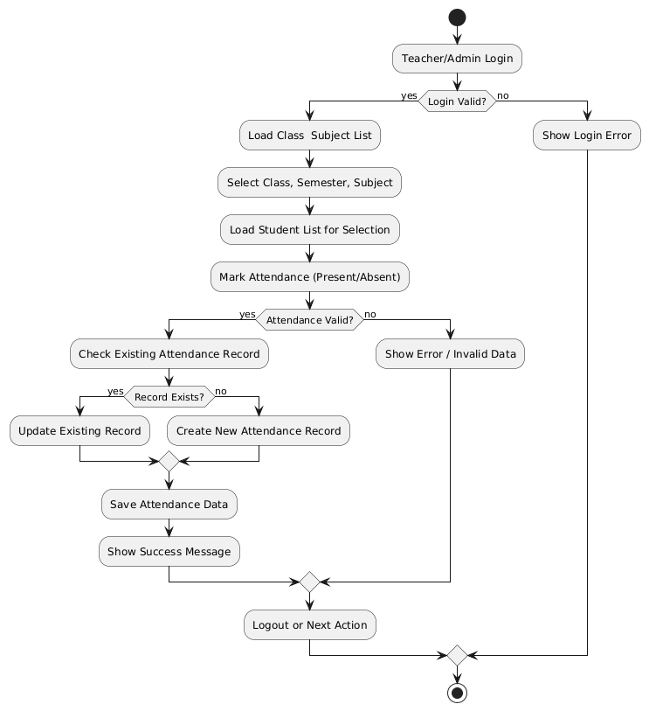

    - Use Case Diagram:-

The Attendance Marking Activity Diagram graphically represents the sequence of actions performed by authorized users to ensure accurate tracking of student attendance within the system. The process initiates with secure user authentication, verifying the identity and permissions of teachers or administrators to access attendance-related functionalities.
Post login, the user selects the relevant class and subject for which attendance is to be marked. The diagram maps the iterative step where the system prompts the user to mark each student's attendance status—present or absent—while simultaneously performing validation checks to detect incomplete or inconsistent data entries.
Upon successful validation, the system either updates existing attendance records or inserts new entries into the database, ensuring data consistency and reliability. Finally, the user receives a confirmation notification indicating the successful completion of the attendance marking task.
This structured activity flow not only promotes data integrity and user accountability but also enhances the overall efficiency of attendance management by minimizing errors and streamlining the recording process.
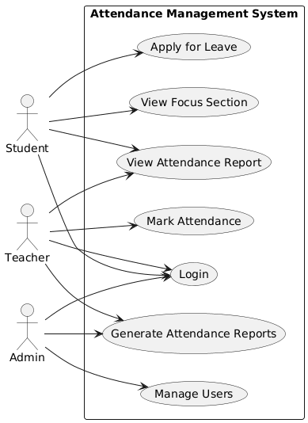

    - Sequence Diagram:-
The Sequence Diagram is a crucial UML diagram that visually captures the time-ordered interactions and message exchanges between various system components involved in the Attendance Management System. It outlines how objects such as students, teachers, the attendance module, and the database interact dynamically to complete processes.
This diagram is especially valuable for illustrating complex workflows, like attendance marking, by detailing each step in the interaction sequence, including user requests, system validations, data retrieval, and updates. Through lifelines and message arrows, the diagram conveys the chronological order of communication between objects, enabling developers to clearly understand and design the system’s runtime behavior.
By providing a stepwise representation of processes, the Sequence Diagram aids in analyzing, validating, and implementing the system architecture effectively. It ensures that all essential events and responses are accounted for, supports troubleshooting, and facilitates clear communication among project stakeholders.
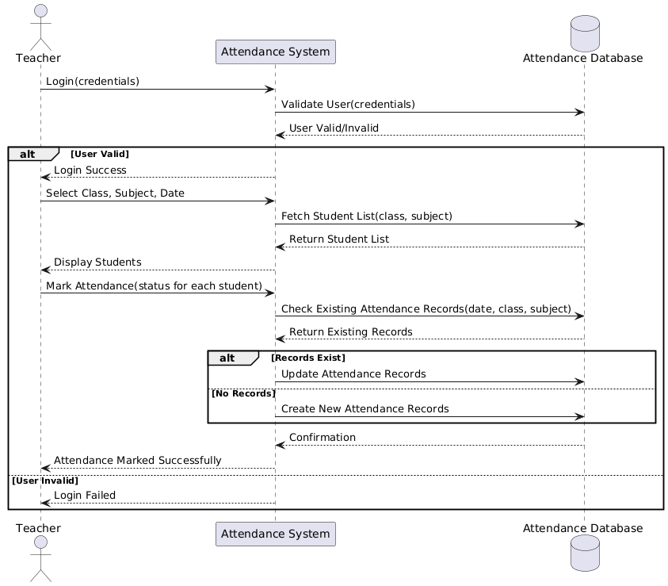

4.3.4 Algorithm:-
Step 1: Start the application.
Step 2: User logs in by entering credentials (Teacher/Admin/Student).
Step 3: If Admin, they can create a new account or manage existing accounts (update/delete).
Step 4: If Teacher, select class, semester, and subject to mark attendance.
Step 5: Load the list of students for the selected class and semester.
Step 6: Mark attendance for each student (Present, Absent, Leave).
Step 7: Validate attendance data for completeness and duplicates.
Step 8: Save attendance records to the database, updating existing records if any.
Step 9: Teachers or Admins can generate attendance reports and view summaries.
Step 10: Students can login using Gmail ID and mobile number to view their personal attendance report.
Step 11: Admin or Teacher can logout when done.
Step 12: Stop the application.

4.4 Security Issues:-
Authentication:-
Authentication in the Attendance Management System is a vital security mechanism that guarantees access to system features strictly to authorized users based on their designated roles—Students, Teachers, or Administrators. It encompasses several rigorous steps to verify and maintain secure user interactions.
User Login: The process begins with users entering their credentials, such as username, email, or password, to prove their identity. The system validates these credentials against securely stored data to authenticate the user.
Password Security: To protect user passwords from unauthorized access, the system employs advanced hashing algorithms. These hashed passwords are stored in the database in an irreversible format, ensuring that even if the database is compromised, user passwords remain confidential.
Role Verification: After successful login, the system identifies the user's role and tailors access accordingly. This role-based access control restricts users to features and modules that are authorized for their role, preventing unauthorized operations within the system.
Failed Login Handling: To safeguard against brute-force attacks, the system tracks multiple unsuccessful login attempts. It triggers preventive actions like temporarily locking the account, requiring CAPTCHA verification, or increasing delay between attempts, thus enhancing overall security.
Session Management: Post authentication, a secure session is initiated for the user, maintaining the logged-in state. The system incorporates measures like session timeouts, regeneration of session identifiers, and protection against session hijacking or fixation attacks, providing sustained security throughout the user's interaction.
This comprehensive authentication framework strengthens the security posture of the Attendance Management System, ensuring data integrity, confidentiality, and user accountability at every stage of access and interaction.

4.5 Test Cases Diagram:-
The Test Cases Diagram visually represents various test scenarios designed to verify the functionality and performance of the Attendance Management System. It typically outlines different modules or features of the system—such as user login, attendance marking, report generation, and notification alerts—and maps them to corresponding test cases.
Each test case defines specific conditions and expected outcomes to validate that the system behaves as intended under various inputs and usage scenarios. The diagram helps testers and developers ensure thorough coverage of system requirements and catch any defects early in the development cycle.
By illustrating the relationships between tests and system components, the Test Cases Diagram promotes structured testing processes, improved communication among team members, and focused quality assurance efforts, ultimately leading to a robust and reliable attendance system.
Test Case ID | Test Case Description | Test Steps | Expected Result | Remarks
TC1 | Registered user login | Enter valid username and password on login page. | User logs in successfully and is redirected to dashboard. | Test with all roles (Student, Teacher, Admin)
TC2 | Unregistered user login | Enter invalid/unregistered username and password. | Proper error message displayed; login form resets. | Verify error message clarity
TC3 | Valid username with empty password | Enter valid username, leave password blank, and submit login. | Error message prompts to enter password; login fails. | UX should highlight empty field
TC4 | Empty username and password | Leave both username and password blank, try logging in. | Error message prompts to enter credentials; login fails. | UX feedback essential
TC5 | Password masking on login form | Observe password field while typing. | Password characters shown as bullets or asterisks. | Prevents shoulder-surfing
TC6 | Attendance submission without student selection | Try to submit attendance without selecting students. | Validation error appears asking to select at least one student. | Prevents incomplete data
TC7 | Duplicate attendance submission | Submit attendance for a date where records already exist. | System asks to update existing records or cancel submission. | Avoids duplicate entries
TC8 | Generate attendance report with valid filters | Select valid date/class/subject and generate report. | Report is generated and displayed correctly. | Checks data accuracy
TC9 | Admin creates new user account | Admin fills and submits new user details form. | New account created; success confirmation shown. | Verify all fields validation
TC10 | Admin deletes user account | Admin selects a user account and deletes it. | User account removed; confirmation displayed; user no longer logs in. | Verify cascade deletions

4.6 User Interface Design:-
The User Interface (UI) design of the Attendance Management System is crafted to provide a seamless, user-friendly, and role-specific experience tailored for its primary users: Students, Teachers, and Administrators. The interface emphasizes simplicity and intuitiveness, enabling users to navigate effortlessly through various functionalities without confusion.
Role-based access ensures that each category of user is presented with relevant options and tools according to their permissions, enhancing security and usability. The design incorporates clear layouts with logically grouped interactive elements such as buttons, forms, and dashboards, allowing efficient execution of common tasks like attendance marking, report viewing, and data management.
Consistency in design aesthetics, responsive layouts for different devices, and meaningful feedback mechanisms (like success confirmations and error alerts) have been prioritized to improve the overall user engagement and satisfaction. This thoughtful design approach significantly contributes to the system’s effectiveness by minimizing user errors and streamlining workflow processes across all user roles.
Login Page(Student):-
The Student Login Page serves as the secure entry point for students to access the Attendance Management System. It typically includes fields where students can enter their registered email (usually their Gmail ID) and mobile number as credentials. This dual authentication method ensures that only valid students gain access to their personalized attendance dashboard.
On successful login, students are redirected to their attendance overview page, where they can view detailed records of their attendance history, attendance percentage, and any notifications or alerts related to attendance.
The page is designed with usability in mind, providing clear input fields and appropriate validation to enhance user experience and minimize login errors. It also supports role selection (Student, Teacher, Admin) to facilitate the correct authentication flow and redirection based on user type.
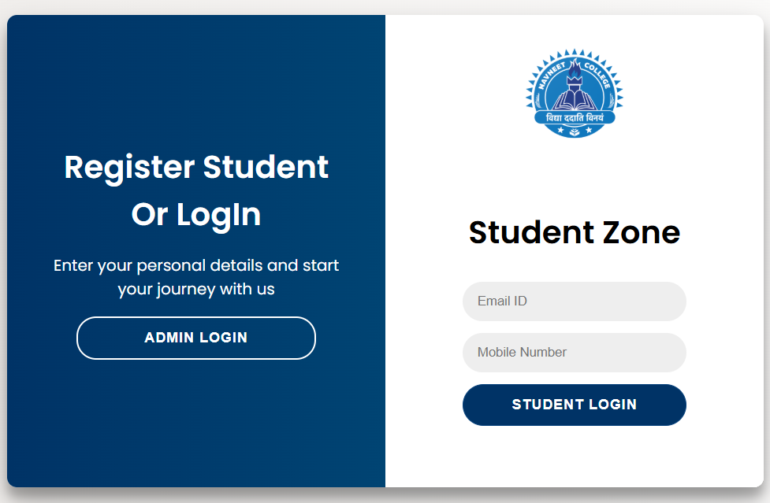
User Dashboard (Student ):-
The Student User Dashboard in the Attendance Management System offers a personalized and easy-to-use interface where students can efficiently access their attendance information. It provides a clear summary of their overall attendance percentage, detailed records of attendance by date and subject, and real-time updates about their attendance status.
Students can view daily attendance entries, track their performance such as present, absent, or leave days, and stay informed about pending leave requests. The dashboard also allows students to submit new leave requests directly, streamlining communication and record-keeping.
Visually, the dashboard integrates charts, progress bars, and status indicators to help students understand their attendance trends over semesters or academic years. This design empowers students to be more responsible by giving them transparency and control over their attendance records.
Under the hood, the dashboard dynamically fetches student-specific attendance data from the database, calculating attendance percentages and presenting reports that help students track their academic engagement. This feature enhances student awareness and supports timely interventions if attendance issues arise.

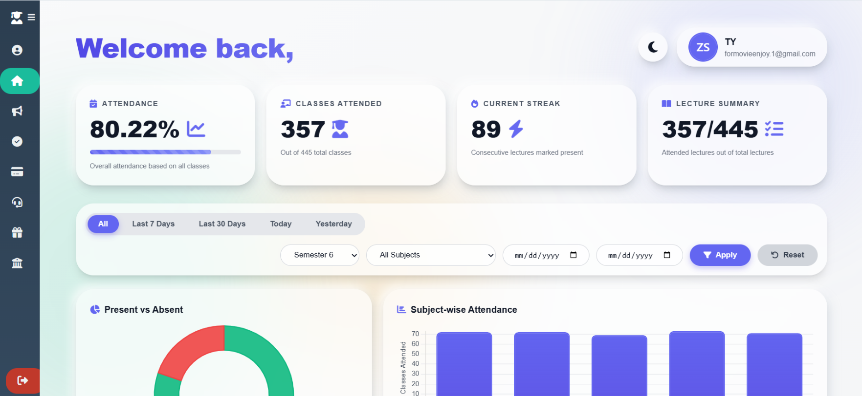

Student Focus :-
The "Focus To Do" section is a centrally featured task management tool within the application. It allows users to efficiently manage and prioritize their study or work tasks alongside their session tracking and timer functionalities. Users can add new tasks with adjustable priority levels (such as Low, Medium, or High) and monitor their progress in real-time.
Each task in the list displays its associated priority, allows for editing or deletion, and is tracked alongside session completion. The section is visually organized for quick recognition, using color-coded priorities and checkboxes for completed or active items. Additionally, visual analytics and history tracking at the bottom of the module provide users with insights into their completed tasks, time spent, and session breakdowns for the day or previous days.
This organized approach helps users remain focused, enhances productivity, and encourages consistent tracking of study or work objectives in a visually appealing and interactive manner.
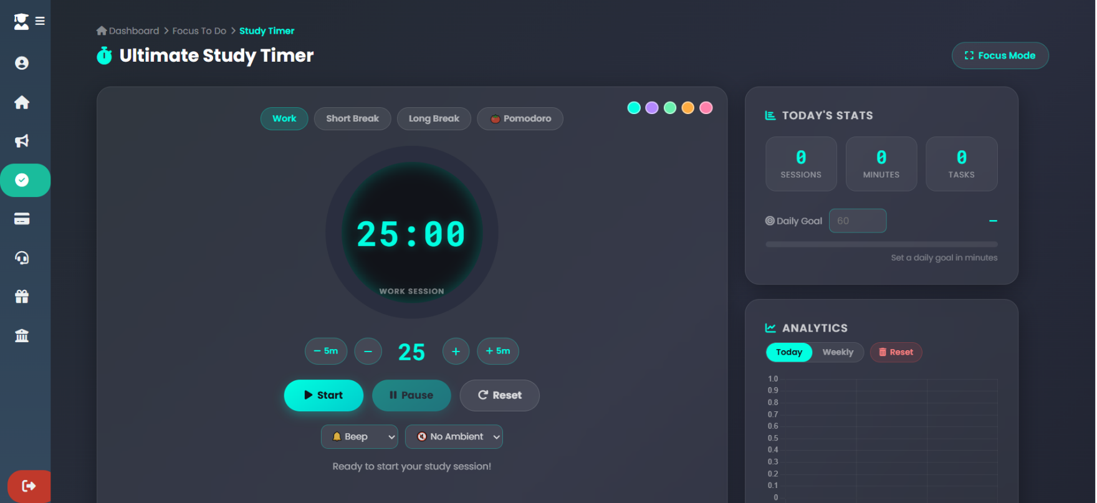

Login Page (Admin):-
The Admin Login Page serves as the secure access gateway for administrative users to manage the Attendance Management System. This page features input fields for the admin username and password, ensuring only authorized personnel can gain entry.
The form typically submits these credentials to the backend, where they are validated against stored admin data. Upon successful authentication, the admin is redirected to the Admin Panel or Dashboard, which offers functionalities such as managing student and teacher records, overseeing attendance data, and generating reports.
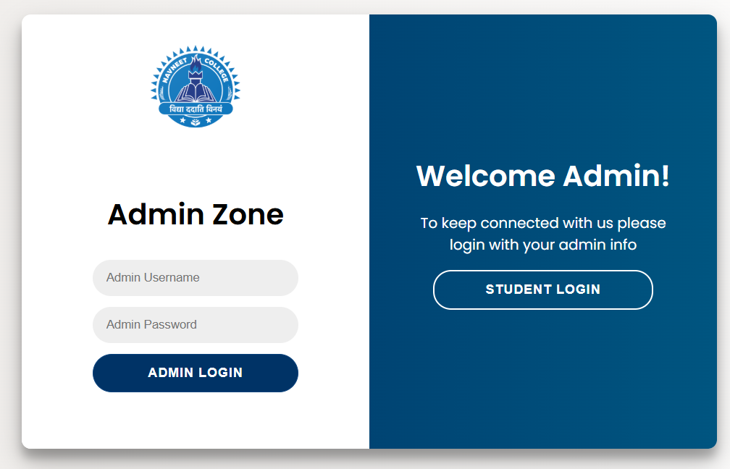
The Admin Login Page is designed with clear input labels and validation checks to prevent errors. It supports secure session management post-login to maintain the admin’s authenticated state. The interface is kept straightforward to facilitate quick and secure access, adhering to the role-based access control policies of the system.

User Dashboard (Admin ):-
The Admin User Dashboard in the Attendance Management System is designed as a centralized control panel that offers administrators comprehensive oversight and management capabilities.
his dashboard provides a real-time overview of system metrics, including total registered students and teachers, attendance summaries, and pending leave requests.
Administrators can easily access functionalities to manage student and teacher accounts, update or delete records, and monitor attendance trends across classes and subjects. The dashboard displays visual analytics and reports that help identify attendance patterns, irregularities, and compliance with institutional policies.
It also includes tools for generating detailed attendance reports, exporting data for audits or record-keeping, and configuring system-wide settings such as user roles and permissions. Interactive elements like charts, notifications, and filters are integrated to enhance usability and support efficient decision-making.
By providing full administrative control and transparent visibility into attendance data, the Admin Dashboard plays a crucial role in maintaining data accuracy, security, and smooth operation across the organization.
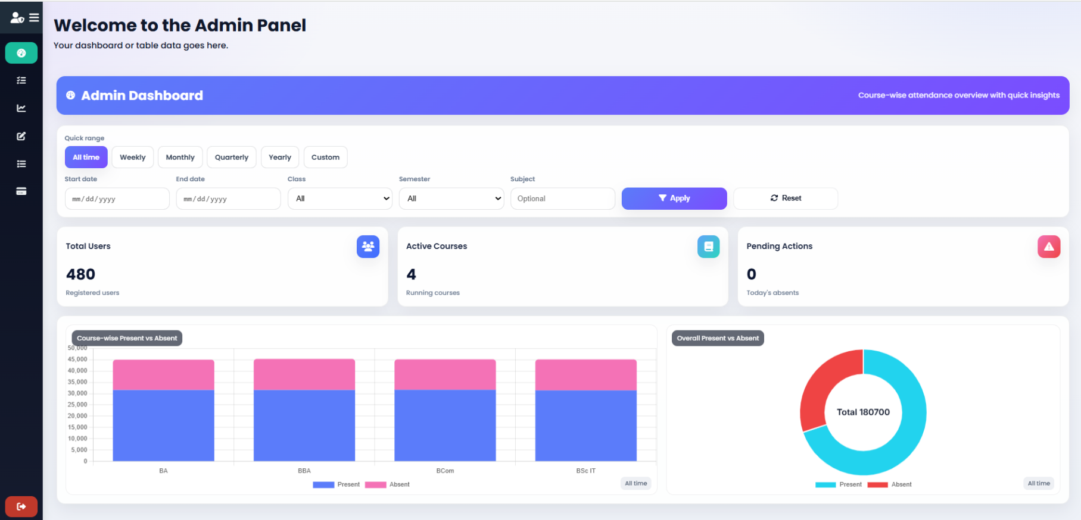
Chapter 5: IMPLEMENTATION AND TESTING
5.1 Implementation Approaches
5.1.1 Implementation Plan
The Implementation Plan of the Attendance Management System outlines the structured sequence of activities carried out to transform system requirements into a fully operational web application. The implementation was executed in a phased and systematic manner to ensure stability, efficiency, and minimal risk during development.
The project followed a step-by-step incremental implementation plan, where each module was developed, tested, and validated before proceeding to the next phase. This approach reduced development complexity and improved overall system reliability.
Phase 1: Environment Setup
- The initial stage involved configuring the development environment:
- Installation of Python and required libraries (Flask, SQLAlchemy, etc.)
- Setup of PostgreSQL database server
- Creation of virtual environment for dependency management
- Configuration of database connectivity
- Initialization of Git for version control
- This phase ensured that the development environment was stable and properly configured for application development.
Phase 2: Database Design and Model Implementation
In this phase, database tables were created based on the ER Diagram and schema design. Core entities such as:
- Student
- Attendance
- Notice
- Fees
were implemented using SQLAlchemy ORM. Primary keys, foreign keys, and constraints were defined to maintain data integrity and enforce relationships between tables.
After model creation, database migrations were performed to synchronize the schema with PostgreSQL.
Phase 3: Authentication System Implementation
The next step involved implementing secure login functionality:
- Role-based login (Student and Teacher/Admin)
- Session management configuration
- Secure session cookies
- Login validation and error handling
- Logout functionality with session clearing
This phase ensured that only authorized users could access respective dashboards.
Phase 4: Core Attendance Module Development
This was the primary functional component of the system. It included:
- Course, Class, Semester, and Subject selection
- Dynamic student list loading
- Attendance marking (Present/Absent)
- Duplicate attendance validation
- Storage of attendance records in the database
Proper validation mechanisms were implemented to prevent duplicate entries for the same date and subject.
Phase 5: Dashboard and Reporting Implementation
After the core module was completed, reporting features were implemented:
- Student attendance percentage calculation
- Teacher attendance summary view
- Low attendance detection (< 75%)
- Overall class performance metrics
- CSV export functionality for attendance reports
Advanced analytical APIs were also developed to generate:
- Course-wise attendance breakdown
- Trend analysis (daily attendance trends)
- Student-wise performance analysis
- Subject-wise heatmap data
Phase 6: Notice and Fees Management Modules
Additional administrative features were implemented to enhance system usability:
- Notice creation, editing, activation/deactivation
- Student notice viewing interface
- Fees tracking per student
- Paid, Partial, and Pending status calculation
- Class-wise fees summary for teachers
These modules expanded the system beyond basic attendance tracking into a more comprehensive academic management solution.
Phase 7: Integration and Testing
In the final phase:
- All modules were integrated
- End-to-end testing was conducted
- Session validation checks were verified
- API responses were tested using browser and developer tools
- Error handling mechanisms were validated
System performance and functionality were verified to ensure smooth operation.
5.2 Coding Details and Code Efficiency:-
Teacher login route :
@app.route('/login', methods=['GET', 'POST'])
def login():
print(f"\nLogin Route - Current Session: {dict(session)}\n")
force_login = (request.args.get('force') == '1')
role = (request.args.get('role') or '').lower()

# Agar already logged in hai aur force nahi kiya to dashboard pe redirect
if session.get('logged_in') and not force_login:
if session.get('user_type') == 'student':
if not get_logged_in_student_email():
session.clear()
flash('Please login first', 'error')
return render_template('login.html', role=role)
return redirect(url_for('student_dashboard'))
return redirect(url_for('teacher_dashboard'))

if request.method == 'POST':
user_type = (request.form.get('user_type') or role or '').lower().strip()
username = (request.form.get('username') or '').strip()
password = (request.form.get('password') or '').strip()

# ─── TEACHER LOGIN ────────────────────────────────────────
if username == 'admin' and password == 'admin123':
session.clear()
session.permanent = True
session['user_id'] = 1
session['user_type'] = 'teacher'
session['logged_in'] = True
session['username'] = 'Teacher'
session.modified = True
print(f"\nTeacher Session Created: {dict(session)}\n")
flash('Teacher login successful', 'success')
return redirect(url_for('teacher_dashboard'))

# Student login (sirf reference ke liye, skip mat karna)
if user_type == 'student':
student = Student.query.filter_by(gmail_id=username, mobile_number=password).first()
if student:
session.clear()
session.permanent = True
session['gmail_id'] = (student.gmail_id or '').strip()
session['email'] = (student.gmail_id or '').strip()
session['user_type'] = 'student'
session['logged_in'] = True
session['username'] = student.full_name
session.modified = True
print(f"\nStudent Session Created: {dict(session)}\n")
flash('Login successful!', 'success')
return redirect(url_for('student_dashboard'))
else:
flash('Invalid student credentials', 'error')
else:
flash('Please select correct user type', 'error')

# GET request → login form dikhao
return render_template('login.html', role=role)
# Quick access routes for teacher
@app.route('/login/teacher')
def login_teacher():
return redirect(url_for('login', role='teacher', force=1))
student login route :
@app.route('/login', methods=['GET', 'POST'])
def login():
print(f"\nLogin Route - Current Session: {dict(session)}\n")
force_login = (request.args.get('force') == '1')
role = (request.args.get('role') or '').lower()

# Agar pehle se logged in hai aur force nahi kiya to dashboard pe redirect
if session.get('logged_in') and not force_login:
if session.get('user_type') == 'student':
if not get_logged_in_student_email():
session.clear()
flash('Please login first', 'error')
return render_template('login.html', role=role)
return redirect(url_for('student_dashboard'))
return redirect(url_for('teacher_dashboard'))

if request.method == 'POST':
user_type = (request.form.get('user_type') or role or '').lower().strip()
username = (request.form.get('username') or '').strip()
password = (request.form.get('password') or '').strip()

# ─── STUDENT LOGIN ────────────────────────────────────────
if user_type == 'student':
student = Student.query.filter_by(
gmail_id=username,
mobile_number=password
).first()

if student:
session.clear()
session.permanent = True
session['gmail_id'] = (student.gmail_id or '').strip()
session['email'] = (student.gmail_id or '').strip()
session['user_type'] = 'student'
session['logged_in'] = True
session['username'] = student.full_name
session.modified = True

print(f"\nStudent Session Created: {dict(session)}\n")
flash('Login successful!', 'success')
return redirect(url_for('student_dashboard'))
else:
flash('Invalid student credentials', 'error')

# Teacher login (sirf reference ke liye)
elif username == 'admin' and password == 'admin123':
# ... teacher code ...
pass

else:
flash('Please select correct user type', 'error')

# GET request → login form dikhao
return render_template('login.html', role=role)

# Quick access route for student
@app.route('/login/student')
def login_student():
return redirect(url_for('login', role='student', force=1))
teacher Dashboard :
@app.route('/teacher_dashboard')
def teacher_dashboard():
if 'user_type' not in session or session['user_type'] != 'teacher':
flash("Please login first as Teacher!", "error")
return redirect(url_for('login'))

return render_template('teacher_dashboard.html')
important API endpoints
# 1. Course-wise Present vs Absent (bar chart ke liye)
@app.get('/api/teacher-dashboard/course-attendance')
def api_course_attendance():
if 'user_type' not in session or session['user_type'] != 'teacher':
return jsonify({'error': 'Unauthorized'}), 401

# ... (filters: range, start_date, end_date, class_yr, semester, subject)
# Yeh endpoint course-wise present aur absent count deta hai
# Response format:
# {
# "labels": ["BSc IT", "BBA", "BCom", ...],
# "present": [450, 320, 280, ...],
# "absent": [120, 90, 110, ...],
# "totals": {"present": 1050, "absent": 320}
# }
# (poora code bahut lamba hai, chahiye to poora bhej dunga)

# 2. Overall KPIs (summary cards)
@app.get('/api/teacher-dashboard/analytics/kpis')
def analytics_kpis():
if 'user_type' not in session or session['user_type'] != 'teacher':
return jsonify({'error': 'Unauthorized'}), 401

# Present, Absent, Total, Avg %, Total Days, Total Students deta hai
# Time range support karta hai (week, month, quarter, year, custom)

# 3. Lowest attendance wale students (top 15)
@app.get('/api/teacher-dashboard/analytics/student-wise')
def analytics_student_wise():
# Lowest % wale students ki list with name, percentage, present, total

# 4. Daily/Trend chart data
@app.get('/api/teacher-dashboard/analytics/trend')
def analytics_trend():
# Date-wise present vs absent (line chart ke liye)

# 5. Subject x Week heatmap data
@app.get('/api/teacher-dashboard/analytics/heatmap')
def analytics_heatmap():
# Subject vs Week ka attendance % heatmap ke liye
Student Dashboard Frontend :
<!DOCTYPE html>
<html lang="en">
<head>
<meta charset="UTF-8">
<meta name="viewport" content="width=device-width, initial-scale=1.0">
<title>Student Dashboard</title>
<link rel="stylesheet" href="https://cdnjs.cloudflare.com/ajax/libs/font-awesome/6.5.0/css/all.min.css">
<script src="https://cdn.jsdelivr.net/npm/chart.js"></script>
<style>
:root{--p:#6366f1;--s:#10b981;--d:#ef4444;--bg:#f8fafc;--card:rgba(255,255,255,0.75);--txt:#1f2937;--muted:#6b7280}
[data-theme=dark]{--bg:#111827;--card:rgba(31,41,55,0.8);--txt:#f3f4f6;--muted:#9ca3af}
body{font-family:system-ui,sans-serif;background:var(--bg);color:var(--txt);margin:0;padding:20px;min-height:100vh}
.container{max-width:1250px;margin:auto}
header{display:flex;justify-content:space-between;align-items:center;margin-bottom:25px;flex-wrap:wrap;gap:15px}
h1{font-size:2.2rem;font-weight:800;background:linear-gradient(90deg,var(--p),#a5b4fc);-webkit-background-clip:text;-webkit-text-fill-color:transparent}
.theme-toggle{background:var(--card);width:50px;height:50px;border-radius:50%;border:none;cursor:pointer;box-shadow:0 4px 15px rgba(0,0,0,0.1)}
.cards{display:grid;grid-template-columns:repeat(auto-fit,minmax(240px,1fr));gap:18px;margin-bottom:30px}
.card{background:var(--card);backdrop-filter:blur(12px);padding:20px;border-radius:18px;border:1px solid rgba(255,255,255,0.1);box-shadow:0 8px 25px rgba(0,0,0,0.08)}
.card h3{color:var(--muted);font-size:0.9rem;margin-bottom:6px}
.card .val{font-size:2.5rem;font-weight:800}
.controls{display:flex;flex-wrap:wrap;gap:12px;background:var(--card);padding:16px;border-radius:16px;margin-bottom:25px}
.controls button,.controls select{padding:10px 16px;border-radius:999px;border:1px solid #ddd;background:transparent}
.controls button{background:var(--p);color:white;border:none;cursor:pointer}
.charts{display:grid;grid-template-columns:1fr 1.6fr;gap:20px}
.chart-card{background:var(--card);padding:20px;border-radius:18px;border:1px solid rgba(255,255,255,0.1);height:340px}
table{width:100%;border-collapse:collapse;margin-top:20px}
th{background:var(--p);color:white;padding:14px;text-align:left}
td{padding:14px;border-bottom:1px solid #eee}
tr:hover{background:rgba(99,102,241,0.05)}
@media(max-width:950px){.charts{grid-template-columns:1fr}}
</style>
</head>
<body data-theme="light">
<div class="container">
<header>
<h1>Welcome back, <span>{{ student.full_name }}</span></h1>
<button class="theme-toggle" id="themeToggle"><i class="fas fa-moon"></i></button>
</header>
<div class="cards">
<div class="card"><h3>Attendance</h3><div class="val">{{ percentage }}%</div></div>
<div class="card"><h3>Classes Attended</h3><div class="val">{{ attended_classes }}</div></div>
<div class="card"><h3>Current Streak</h3><div class="val">{{ current_streak }}</div></div>
<div class="card"><h3>Total Lectures</h3><div class="val">{{ attended_classes }}/{{ total_classes }}</div></div>
</div>

<div class="controls">
<select id="period"><option>All</option><option>Last 7 Days</option><option>Last 30 Days</option></select>
<select id="semesterFilter">
{% for sem in ['1','2','3','4','5','6'] %}<option value="{{ sem }}">{{ sem }}</option>{% endfor %}
</select>
<select id="subjectFilter"><option>All Subjects</option></select>
<button id="applyBtn"><i class="fas fa-filter"></i> Apply</button>
</div>

<div class="charts">
<div class="chart-card">
<h3><i class="fas fa-chart-pie"></i> Present vs Absent</h3>
<canvas id="pieChart"></canvas>
</div>
<div class="chart-card">
<h3><i class="fas fa-chart-bar"></i> Subject-wise Attendance</h3>
<canvas id="barChart"></canvas>
</div>
</div>

<div style="margin-top:30px">
<h3><i class="fas fa-table"></i> Recent Attendance</h3>
<table id="attendanceTable">
<thead><tr><th>Date</th><th>Subject</th><th>Status</th><th>Time</th></tr></thead>
<tbody id="tableBody"></tbody>
</table>
</div>
</div>

<script>
// Theme Toggle
document.getElementById('themeToggle').addEventListener('click', () => {
const isDark = document.body.dataset.theme === 'dark';
document.body.dataset.theme = isDark ? 'light' : 'dark';
document.getElementById('themeToggle').innerHTML = isDark ? '<i class="fas fa-moon"></i>' : '<i class="fas fa-sun"></i>';
});

// Fake Data (replace with real fetch later)
const fakeData = {
pie: [82, 18],
barLabels: ["DBMS", "CN", "OS", "Python", "Java"],
barData: [28, 22, 31, 19, 24]
};

// Pie Chart
new Chart(document.getElementById('pieChart'), {
type: 'doughnut',
data: {
labels: ['Present', 'Absent'],
datasets: [{ data: fakeData.pie, backgroundColor: ['#10b981', '#ef4444'] }]
},
options: { cutout: '65%', responsive: true, maintainAspectRatio: false }
});

// Bar Chart
new Chart(document.getElementById('barChart'), {
type: 'bar',
data: {
labels: fakeData.barLabels,
datasets: [{ label: 'Attended', data: fakeData.barData, backgroundColor: '#6366f1', borderRadius: 8 }]
},
options: { responsive: true, maintainAspectRatio: false, scales: { y: { beginAtZero: true } } }
});

// Simple Table (demo)
document.getElementById('tableBody').innerHTML = `
<tr><td>24 Mar 2025</td><td>DBMS</td><td style="color:#10b981">Present</td><td>09:30</td></tr>
<tr><td>23 Mar 2025</td><td>CN</td><td style="color:#ef4444">Absent</td><td>11:00</td></tr>
`;

// Apply button demo
document.getElementById('applyBtn').addEventListener('click', () => alert('Filters Applied (Demo)'));
</script>
</body>
</html>
Student Dashboard Backend:
@app.route('/student_dashboard')
def student_dashboard():
print(f"\nDashboard Access Attempt - Session: {dict(session)}\n")

# ─── Authentication check ────────────────────────────────────────────────
required_keys = ['logged_in', 'user_type']
if not all(key in session for key in required_keys):
print("Missing session keys:", [key for key in required_keys if key not in session])
flash('Please login first', 'error')
return redirect(url_for('login'))

if session['user_type'] != 'student':
print("Invalid user type, redirecting to login")
flash('Unauthorized access', 'error')
return redirect(url_for('login'))

gmail_id = get_logged_in_student_email()
if not gmail_id:
print("Student session missing email identifier, forcing re-login")
session.clear()
flash('Please login first', 'error')
return redirect(url_for('login'))

if not session.get('gmail_id'):
session['gmail_id'] = gmail_id

# ── Global academic filter: query param > session > DB ───────────────────
qp_semester = canonical_semester(
request.args.get('semester') or request.form.get('selected_semester') or ''
)
_, sess_sem = get_active_filter(gmail_id)
selected_semester = qp_semester or sess_sem

# Agar query param se semester aaya to session mein save kar do
if qp_semester and qp_semester != sess_sem:
save_active_filter(session.get('active_class', ''), qp_semester)

selected_period = (request.args.get('period') or 'all').strip().lower()
selected_subject = (request.args.get('subject') or '').strip()

# Student object + semester resolve karo
student, selected_semester = get_student_for_email_semester(
gmail_id,
selected_semester
)

if not student:
print("Student not found in DB, clearing session")
session.clear()
flash('Student not found', 'error')
return redirect(url_for('login'))

# Final semester value (active filter ya student DB se)
semester_value = canonical_semester(student.semester or selected_semester or "")
active_class, active_sem = get_active_filter(gmail_id)
if active_sem:
semester_value = active_sem
if not semester_value:
semester_value = selected_semester or "1"

print(f"[dashboard] Active Class: {active_class!r}")
print(f"[dashboard] Active Semester: {semester_value!r}")
print(f"[dashboard] Period: {selected_period!r} Subject filter: {selected_subject!r}")

# ── Attendance records fetch ─────────────────────────────────────────────
records_q = build_student_dashboard_filtered_query(
gmail_id,
semester_value,
selected_period,
selected_subject
)

records = records_q.order_by(
Attendance.date.desc(), Attendance.attendance_id.desc()
).all()

total_classes = len(records)
attended_classes = sum(1 for r in records if normalize_status(r.status) == "present")
percentage = round((attended_classes / total_classes) * 100, 2) if total_classes > 0 else 0
current_streak = calculate_current_streak(records)

print(f"[dashboard] Total Records: {total_classes} Present: {attended_classes} Pct: {percentage}%")

# Notices (pinned + important pehle)
notices = Notice.query.filter_by(is_active=True)\
.order_by(Notice.is_pinned.desc(), Notice.date_posted.desc())\
.all()

# Template ke liye initial records (JS mein chart ke liye use hote hain)
initial_records = [{
"date": r.date.isoformat() if r.date else "",
"time": format_lecture_time(r.time),
"subject": r.subject or "",
"status": r.status or "",
"marked_by": r.marked_by or "",
"remarks": r.remarks or ""
} for r in records]

return render_template('student_dashboard.html',
student=student,
notices=notices,
records=records,
initial_records=initial_records,
selected_semester=semester_value,
percentage=percentage,
attended_classes=attended_classes,
total_classes=total_classes,
current_streak=current_streak)
Logout :
@app.route('/logout')
def logout():
print(f"Logging out user: {dict(session)}") # Debugging ke liye session print

session.clear() # Saari session keys delete kar deta hai

print("After clear session:", dict(session)) # Confirm karne ke liye

flash('You have been logged out successfully', 'success')

return redirect(url_for('login'))

5.2.1 Code Efficiency
Code efficiency plays a crucial role in ensuring that the Attendance Management System performs optimally, especially when handling large volumes of attendance records, student data, and analytical queries. During the development process, several strategies were adopted to improve execution speed, reduce memory usage, and enhance maintainability.
Efficient Database Operations
Instead of processing large datasets at the application level, most computations are performed directly at the database level using SQLAlchemy’s aggregation functions. Functions such as:
- COUNT() for total attendance days
- SUM() for counting present and absent records
- CASE() for conditional aggregation
- GROUP BY for student-wise and course-wise summaries
allow calculations to be executed within PostgreSQL, significantly reducing data transfer overhead between the database and application server.
Date filtering is efficiently implemented using BETWEEN queries, ensuring optimized retrieval of records within selected time ranges.
Avoidance of Redundant Queries
- To prevent unnecessary database calls:
- Filters are applied before querying large datasets.
- Subqueries are used where appropriate to reduce repeated queries.
- Distinct queries are used to fetch unique subjects and course data.
- This approach minimizes server load and improves response time.
Connection Pooling and Resource Optimization
- SQLAlchemy engine options were configured to improve database performance:
- pool_pre_ping ensures active database connections.
- pool_recycle prevents stale connections.
- pool_size and max_overflow manage concurrent user access.
- These configurations allow the system to handle multiple users efficiently without connection failures.
Session Management Optimization
Efficient session handling reduces unnecessary re-authentication while maintaining security. The system uses:
- Controlled session lifetime
- Session refresh on each request
- Secure cookie configuration
This ensures minimal overhead while preserving user authentication state.
Memory-Efficient Data Export
The CSV export functionality uses in-memory streams (io.StringIO) instead of creating temporary files on disk. This approach:
Reduces disk I/O operations
Improves export speed
Minimizes server storage usage
Thus, report generation remains efficient even for large datasets.
Reusable Helper Functions
- Common functionalities such as:
- Date parsing
- Range resolution for dashboards
- Percentage calculations
- Filter application
are implemented as reusable helper functions. This reduces code duplication, simplifies debugging, and improves maintainability.
Optimized API Responses
Dashboard APIs return lightweight JSON responses instead of rendering full templates. This:
- Reduces server-side rendering overhead
- Improves frontend responsiveness
- Enables dynamic chart updates without page reload
Such API-based implementation significantly enhances user experience and system performance.

5.3 Testing Approaches
Testing is a critical phase in the development of the Attendance Management System, ensuring that all modules function correctly, efficiently, and securely. Various testing approaches were adopted to validate system functionality, detect errors, and improve overall performance.
The system was tested using a combination of manual and functional testing techniques. Each module, including authentication, attendance marking, reporting, and dashboard analytics, was verified under different conditions to ensure accuracy and reliability.
Functional testing was performed to validate whether the system meets all specified requirements. This includes checking login functionality, attendance entry validation, report generation, and role-based access control.
Integration testing was carried out to ensure that different modules of the system work together seamlessly. For example, attendance marking was tested along with database storage and report generation to confirm proper data flow.
User interface testing ensured that all pages are responsive, user-friendly, and free from layout issues. Special attention was given to navigation, form inputs, dropdown selections, and dashboard interactions.
Error handling and validation testing were implemented to check how the system behaves under invalid inputs, such as incorrect login credentials, empty form submissions, or duplicate attendance entries.
Overall, the testing approach ensured that the system is reliable, user-friendly, and capable of handling real-world usage scenarios effectively.

5.3.1 Unit Testing
Unit Testing is performed to verify the functionality of individual components or modules of the Attendance Management System independently. Each function and module is tested in isolation to ensure it performs as expected.
In this system, unit testing focuses on backend logic, database operations, and utility functions. Key areas tested include:
· Authentication Module:
Verifies login functionality, credential validation, and role-based access control for students, teachers, and administrators.
· Attendance Module:
Tests the logic for marking attendance, validating duplicate entries, and storing attendance data correctly in the database.
· Database Operations:
Ensures that CRUD (Create, Read, Update, Delete) operations using SQLAlchemy are executed accurately without data inconsistencies.
· Helper Functions:
Validates reusable functions such as date filtering, attendance percentage calculation, and data formatting.
· Validation Logic:
Checks input validations such as required fields, correct data formats, and prevention of invalid entries.
Each unit test ensures that the respective module works correctly before integration with other components. This helps in early detection of bugs and simplifies debugging.
Unit testing improves code quality, reliability, and maintainability by ensuring that individual parts of the system function correctly under different conditions.
Before Admin login page Test :
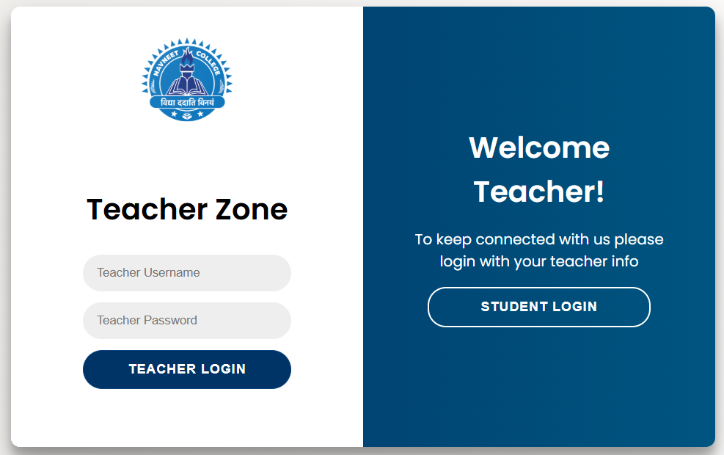
After Admin login page Test :
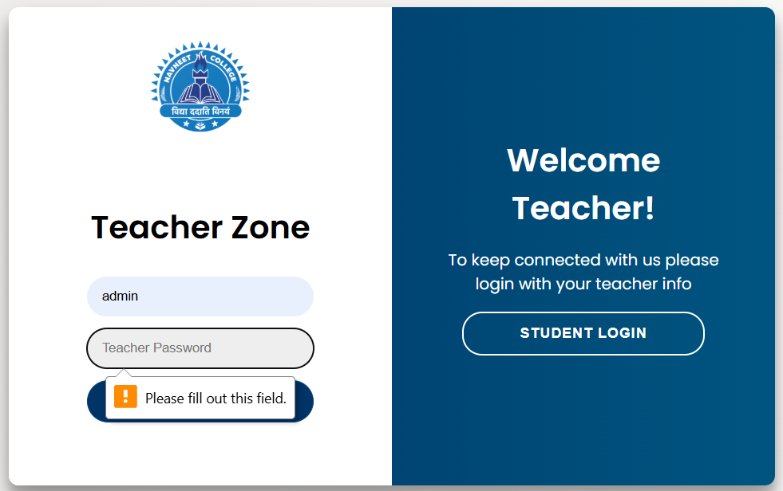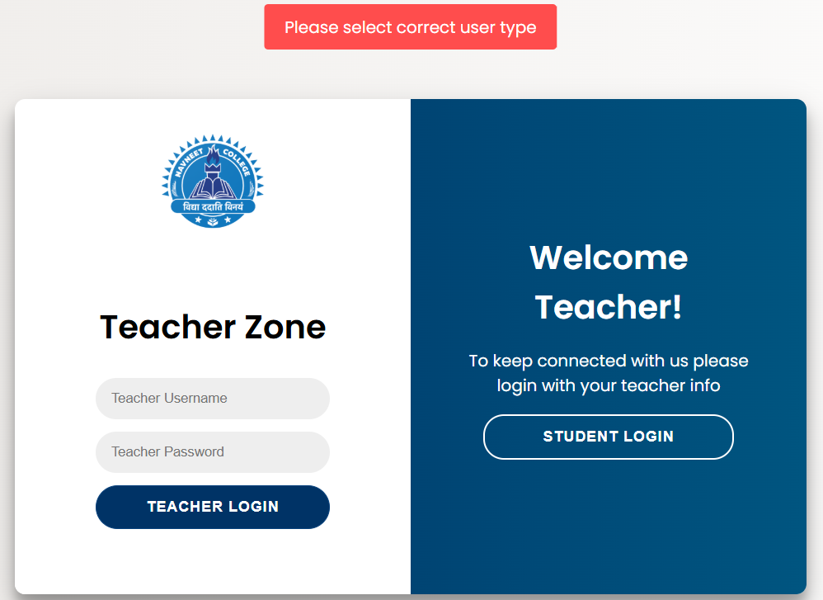

Before Student login page Test:
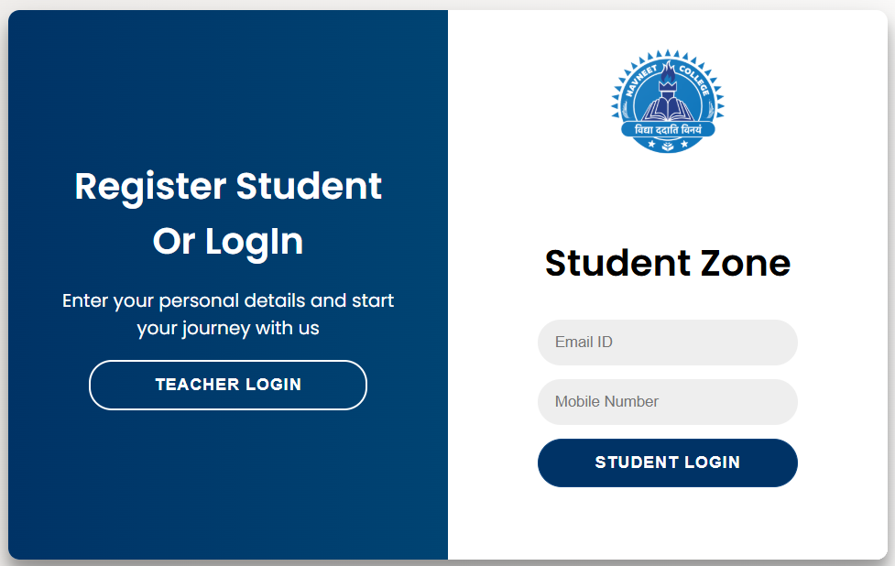

After Student login page Test :
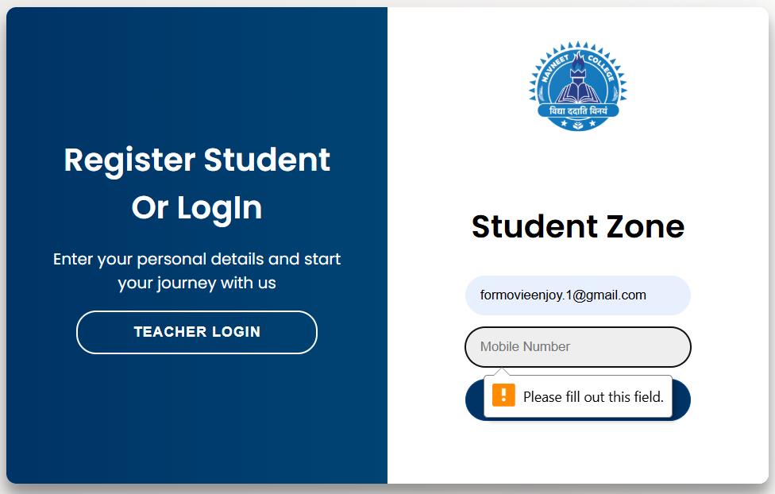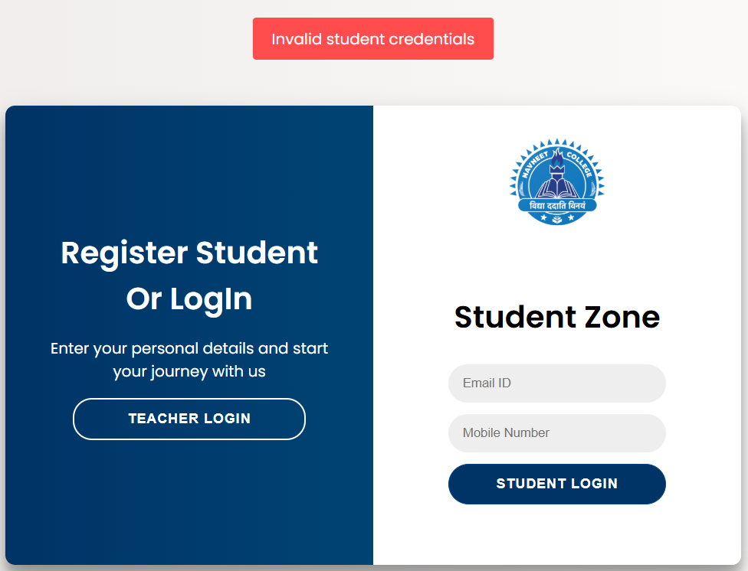

5.3.2 Integrated Testing
Integration Testing is conducted to verify that different modules of the Attendance Management System work together correctly as a unified system. After individual components are tested through unit testing, integration testing ensures smooth data flow and interaction between these components.
In this system, multiple modules such as authentication, attendance management, reporting, and dashboard analytics are interconnected. Integration testing validates that these modules communicate effectively without errors or data inconsistencies.
The following integration scenarios were tested:
· Authentication and Dashboard Integration:
Ensures that after successful login, users (Student, Teacher, Admin) are redirected to their respective dashboards with correct data access permissions.
· Attendance and Database Integration:
Verifies that attendance marked by teachers is correctly stored in the database and can be retrieved accurately for reports and student views.
· Attendance and Reporting Integration:
Checks whether attendance data is properly reflected in generated reports, summaries, and analytics dashboards.
· Filtering and Data Retrieval:
Ensures that filters such as class, semester, subject, and date range correctly fetch and display relevant attendance data.
· Notice and User Interface Integration:
Validates that notices created by the admin are properly displayed to students and teachers within their dashboards.
· Session and Security Integration:
Confirms that user sessions are maintained correctly across pages and unauthorized access is restricted.
Integration testing helps identify issues related to data flow, module dependency, and system interaction. It ensures that the entire system operates smoothly as a complete application.
Overall, integration testing enhances system reliability and ensures that all components function cohesively to deliver accurate and consistent results.

Admin Mark Attendance :
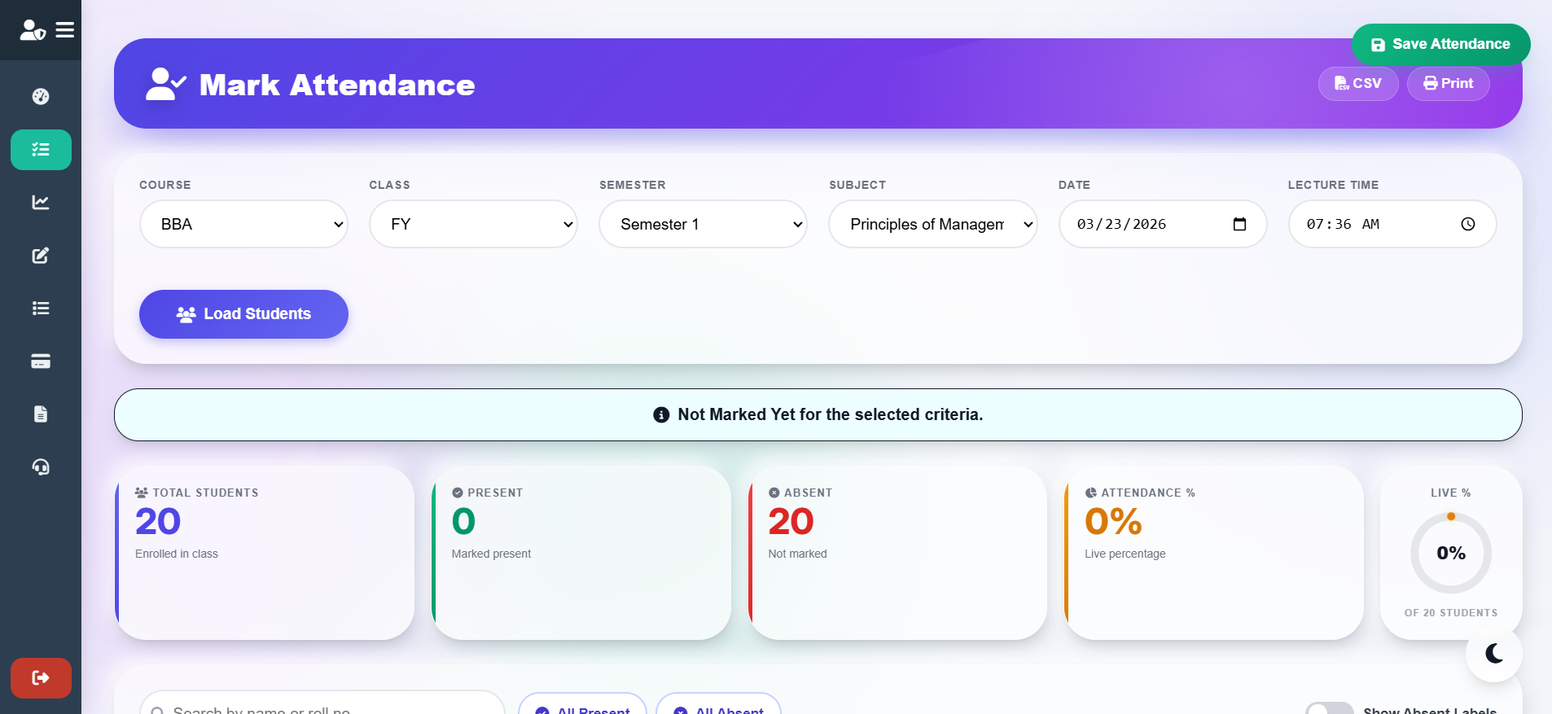

Admin Fees handing:
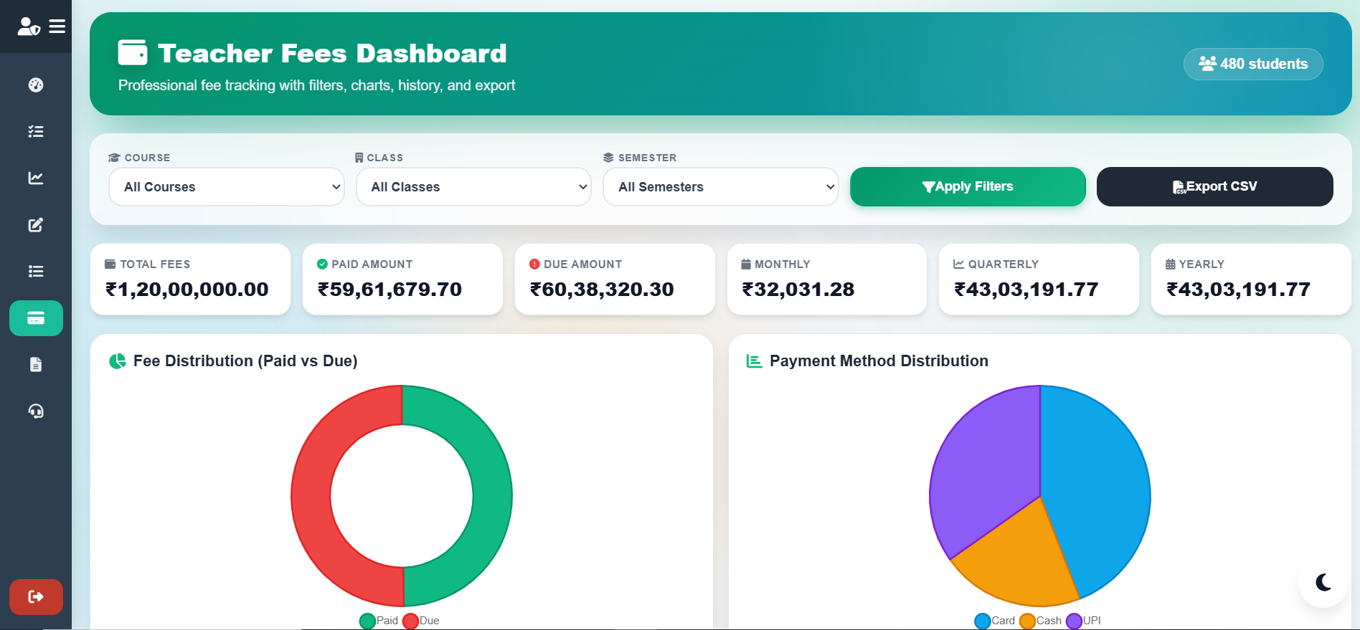

Admin Support Center :
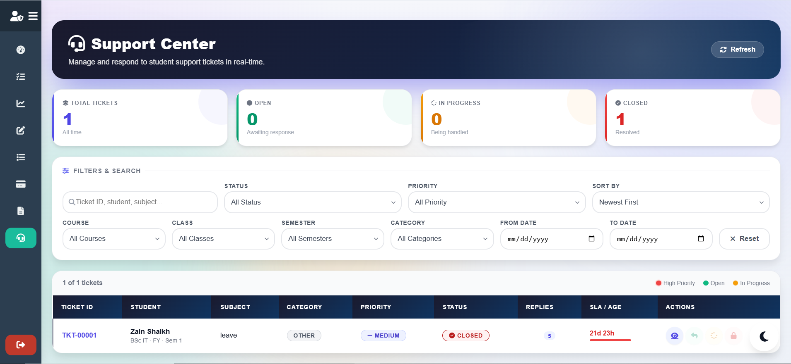

5.3.3 Beta Testing:-
Beta Testing is performed to evaluate the Attendance Management System in a real-world environment with actual users before final deployment. This phase helps in identifying usability issues, unexpected errors, and performance gaps that may not be detected during earlier testing stages.
In this system, beta testing involves allowing a limited group of users such as students, teachers, and administrators to interact with the application and provide feedback based on their experience.
The following aspects were evaluated during beta testing:
· User Experience and Interface:
Users tested the system’s interface to ensure it is easy to navigate, visually clear, and responsive across different devices.
· Functionality Testing:
All major features such as login, attendance marking, report generation, and dashboard analytics were tested under real usage conditions.
· Performance Under Load:
The system was observed for performance when multiple users accessed the system simultaneously, ensuring smooth operation without lag.
· Error Identification:
Users reported any bugs, incorrect outputs, or system crashes encountered during usage.
· Feedback Collection:
Feedback from users was collected to improve system design, functionality, and usability.
· Compatibility Testing:
The system was tested on different browsers and devices to ensure consistent performance.
Based on the feedback received during beta testing, necessary improvements and refinements were made to enhance system stability and user satisfaction.
Overall, beta testing ensured that the system is practical, user-friendly, and ready for deployment in an actual academic environment.

Student Profile :
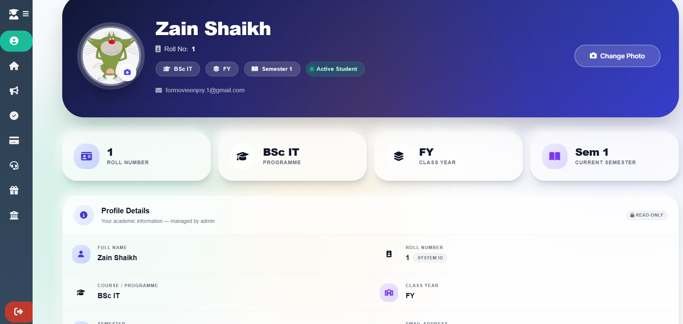

Student ID Card & Bonafide Certificate :
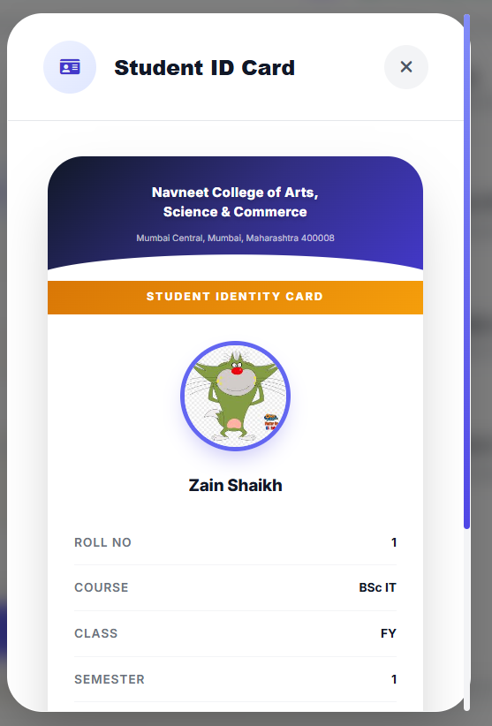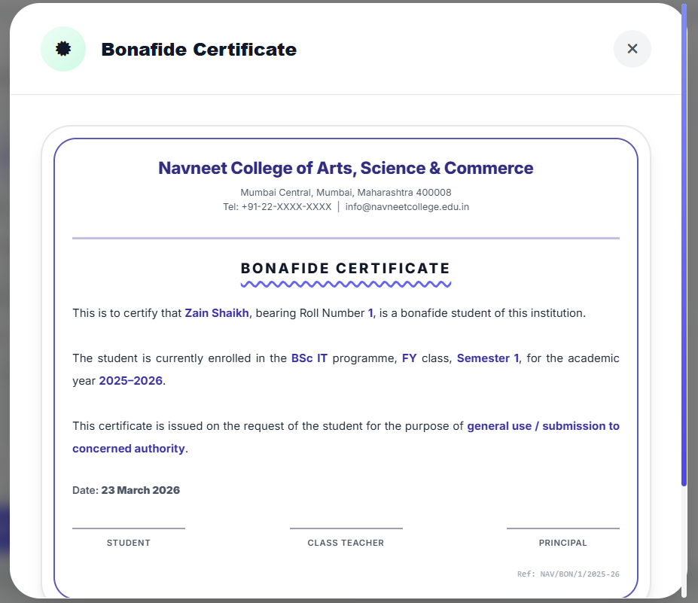

5.4 Modification and Improvements:-
During the development and testing phases of the Attendance Management System, several modifications and improvements were implemented to enhance system performance, usability, and reliability. These changes were primarily based on testing results, user feedback, and observed system limitations.
The system was continuously refined to ensure smooth operation and better user experience. Key modifications and improvements include:
· User Interface Enhancements:
The layout and design of dashboards and forms were improved to make the system more intuitive and user-friendly. Proper alignment, spacing, and responsive design were implemented to ensure consistency across devices.
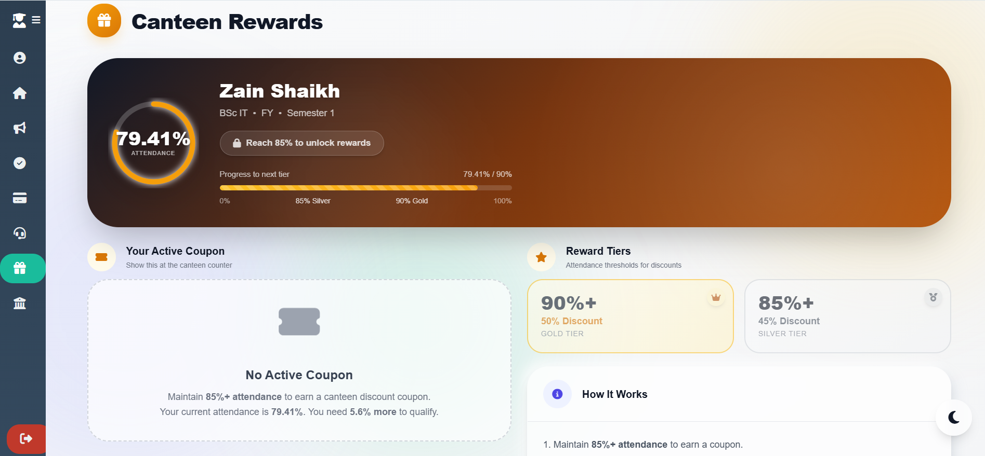
· Bug Fixes and Error Handling:
Various issues identified during testing, such as incorrect data display, form submission errors, and navigation problems, were resolved. Improved validation and error messages were added to guide users effectively.
Getting error while improving the UI dashboard
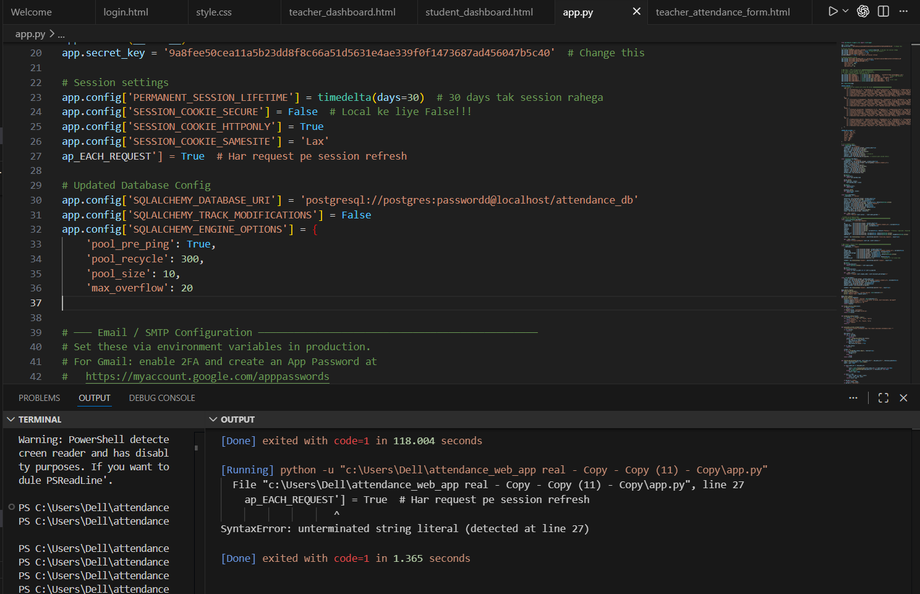
Correted this error and fixcing the bug
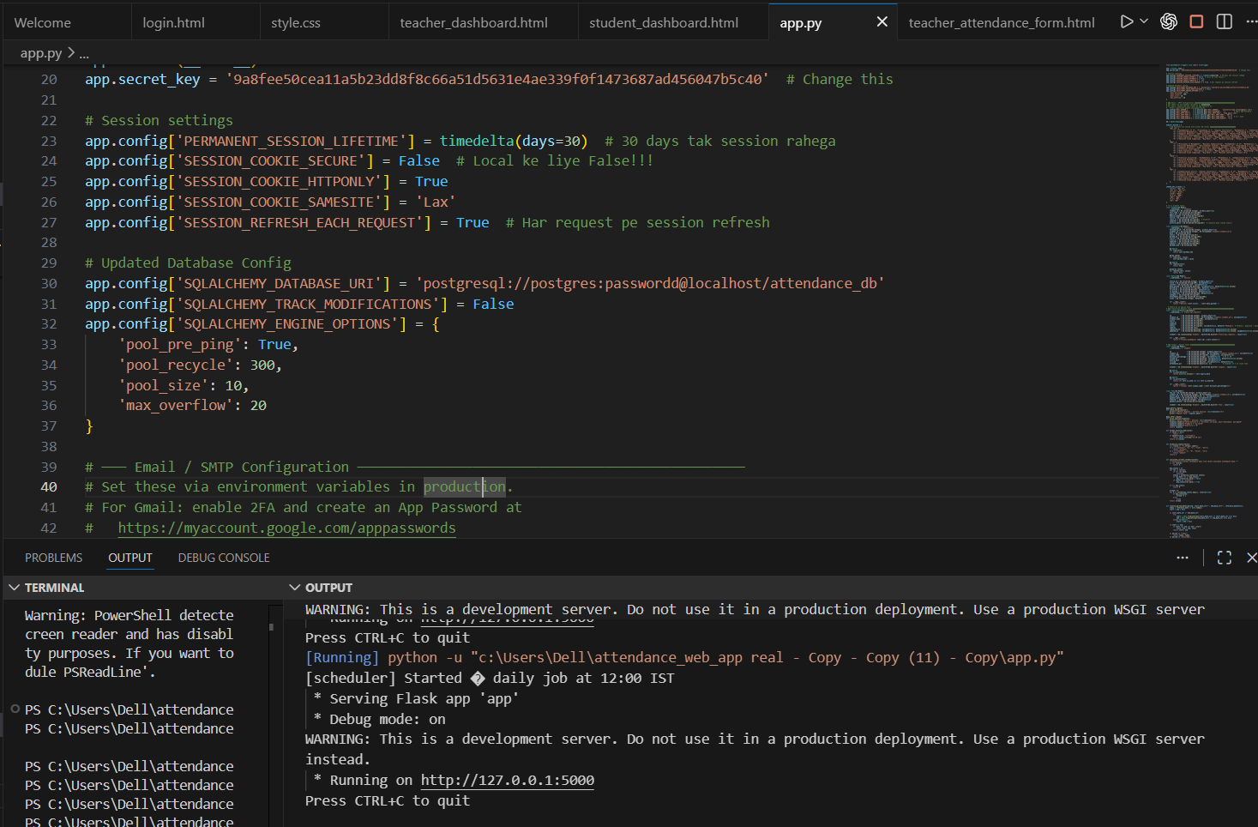
· Performance Optimization:
Database queries were optimized to reduce response time and improve system speed. Efficient filtering and data retrieval techniques were applied to handle large datasets smoothly.
· Attendance Validation Improvements:
Additional checks were implemented to prevent duplicate attendance entries and ensure accurate data recording for each student and subject.
· Session and Security Improvements:
Enhancements were made in session management to maintain secure login sessions and prevent unauthorized access. Secure authentication practices were strengthened.
· Feature Enhancements:
New functionalities such as improved filtering options, better report generation, and enhanced dashboard analytics were added based on user requirements.
· Compatibility Improvements:
The system was tested and optimized for different browsers and devices to ensure consistent performance and accessibility.
These modifications significantly improved the overall efficiency, stability, and usability of the system. Continuous improvement ensures that the system remains adaptable to future requirements and technological advancements.
5.5 Test Cases:-
Test Cases are an essential part of the testing process, used to validate the functionality, performance, and reliability of the Attendance Management System. They define specific conditions under which the system is tested and ensure that all features work as expected.
Each test case includes inputs, execution steps, expected outputs, and actual results. These test cases help in identifying errors, verifying system behavior, and ensuring that all modules meet the required specifications.
The system was tested using a variety of test scenarios covering different modules such as authentication, attendance management, reporting, and user interaction. The following aspects were considered while designing test cases:
· Login Functionality:
Test cases were created to verify successful login with valid credentials and proper error handling for invalid or empty inputs.
· Attendance Marking:
Test cases ensured that attendance can be marked correctly for students and validated to prevent duplicate entries.
· Data Validation:
Various input validation scenarios were tested, including empty fields, incorrect formats, and missing data.
· Report Generation:
Test cases verified that attendance reports are generated accurately based on selected filters such as class, subject, and date range.
· User Role Access:
Different user roles (Student, Teacher, Admin) were tested to ensure that each role has appropriate access permissions.
· Error Handling:
The system was tested for handling unexpected inputs and system errors without crashing.
· Data Consistency:
Test cases ensured that data stored in the database remains accurate and consistent across different modules.
The detailed test cases, including test case IDs, descriptions, steps, and expected results, are presented in the previous section. These test cases ensured that the system operates reliably under various conditions.

CHAPTER 6: RESULT AND DISCUSSION
6.1 Test Reports:-
Test Reports provide a comprehensive summary of the testing activities performed on the Attendance Management System. These reports help in evaluating system performance, identifying defects, and confirming that all functionalities meet the specified requirements.
The testing process was conducted systematically across all modules, including authentication, attendance management, reporting, and user interface. Each module was tested under different scenarios to ensure correctness, reliability, and efficiency.
The following observations were recorded during testing:
Student Dashboard :
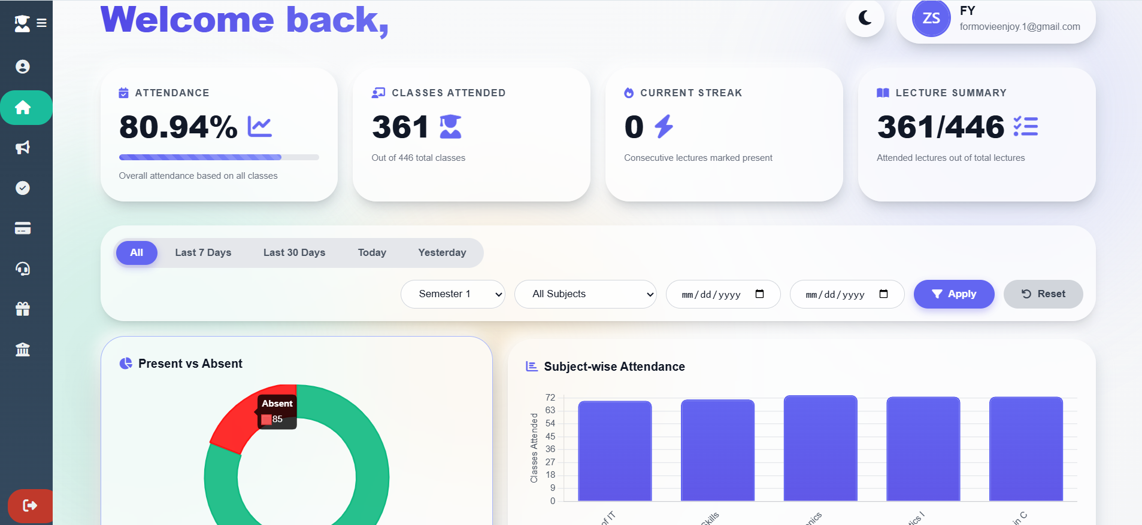

Student Notice :
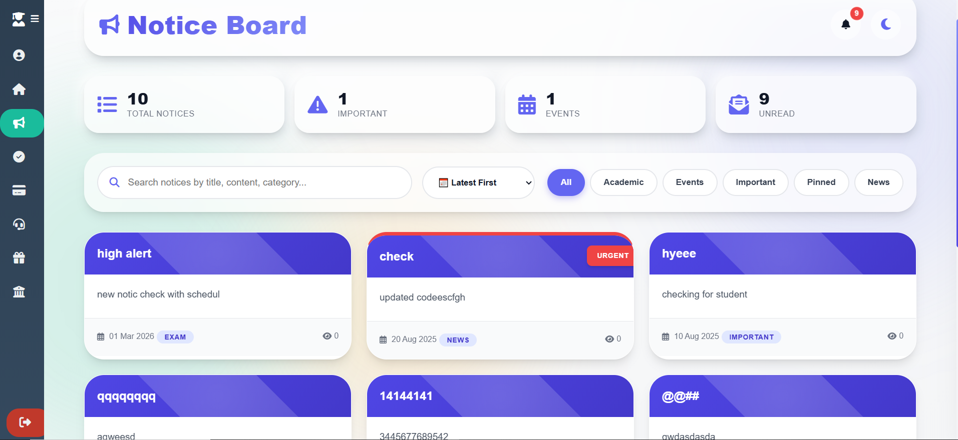

Student Fees :
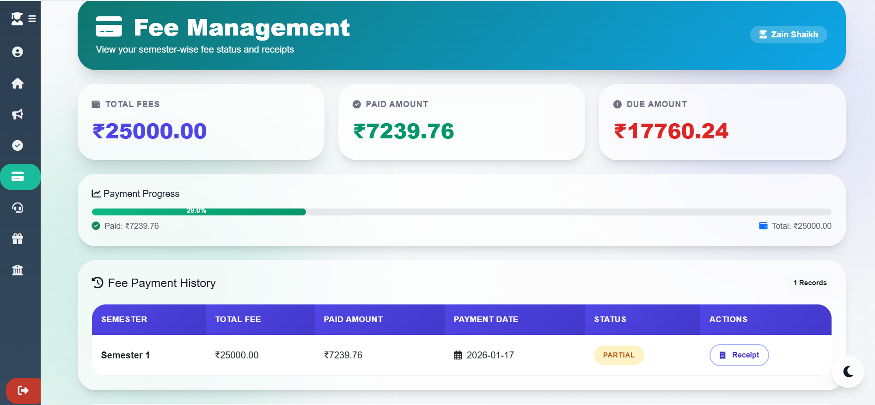

Student Help & Support :
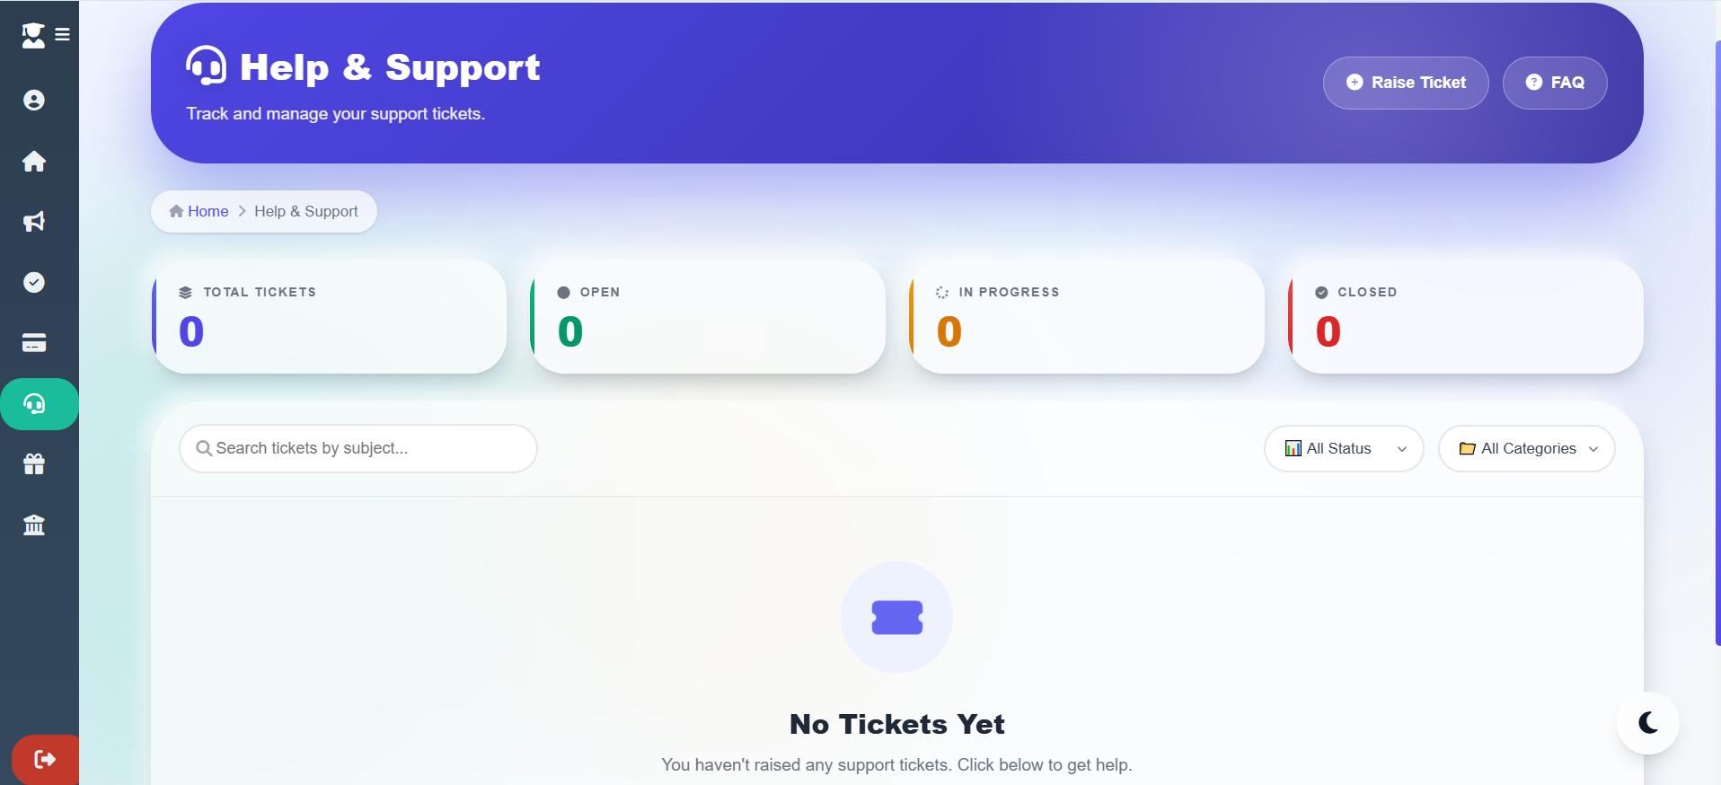

Teacher Dashboard :
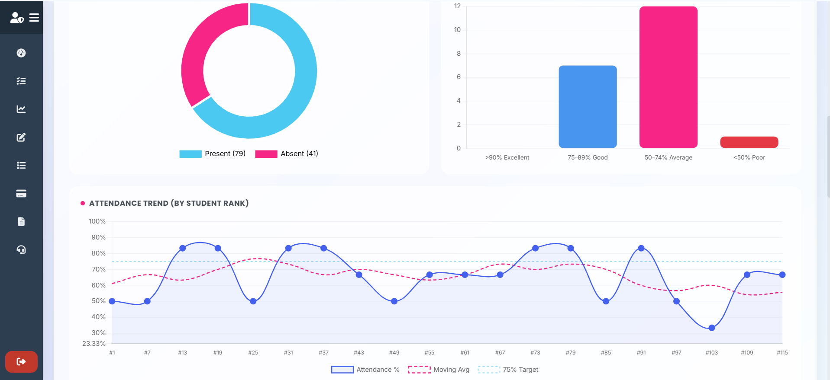

Teacher Notices :
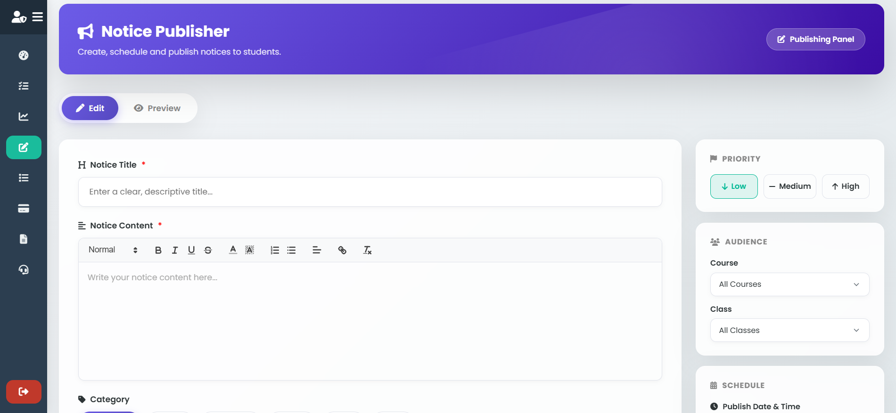

Teacher View Notices :
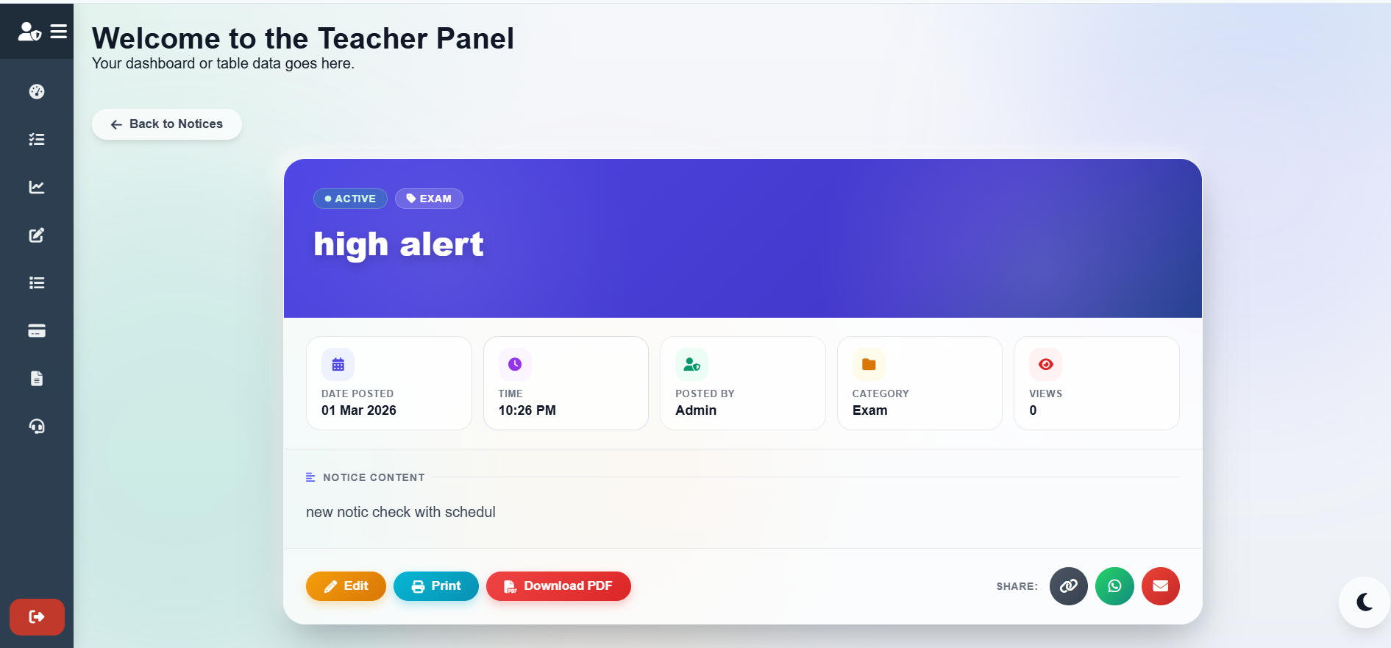

Teacher Edit Notices :
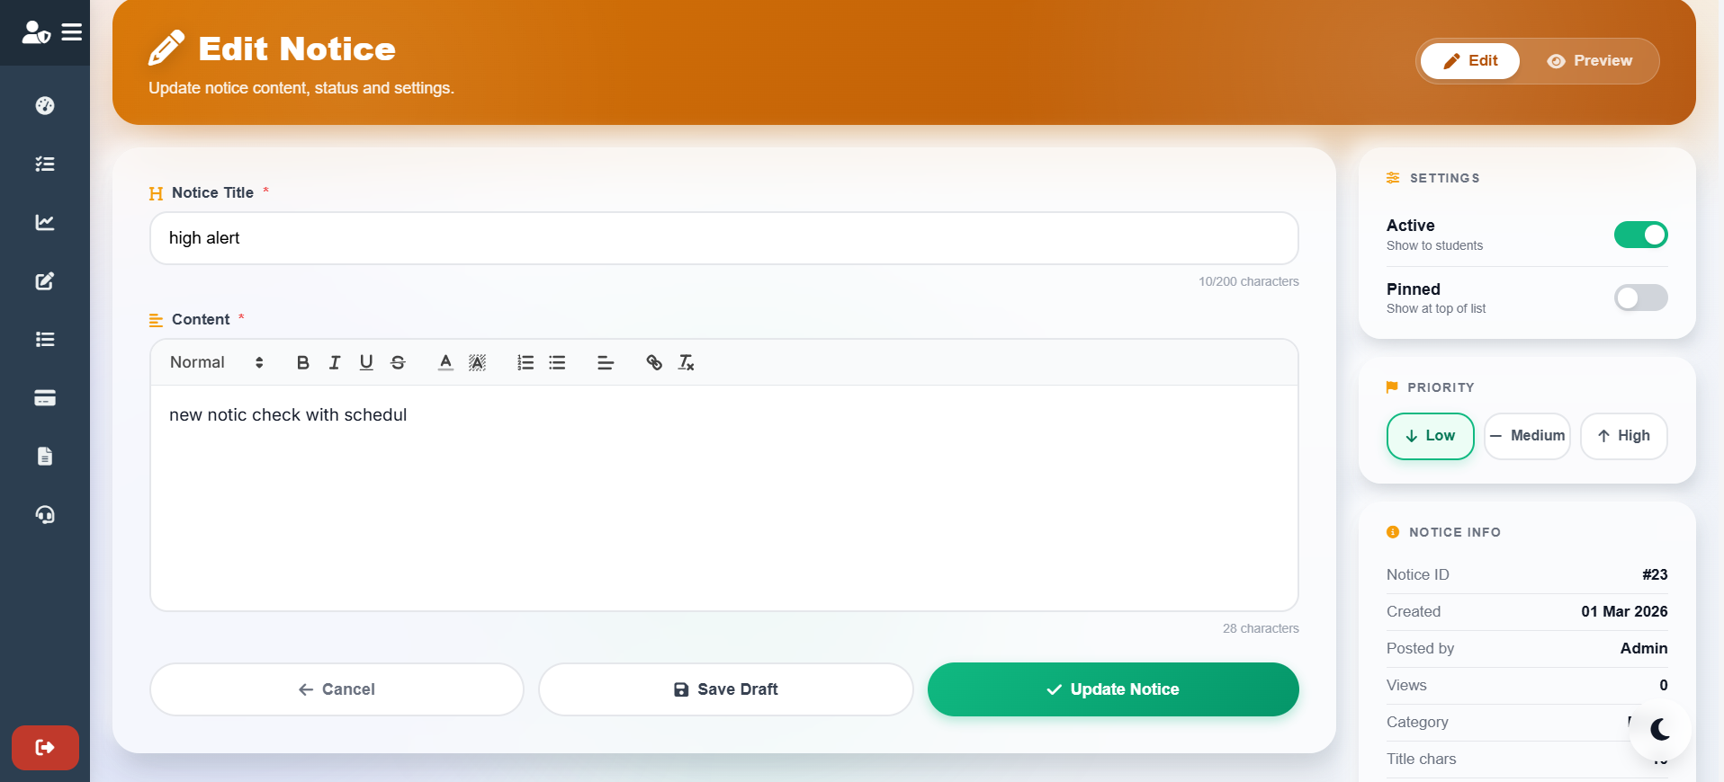

Teacher Transcript Requests :
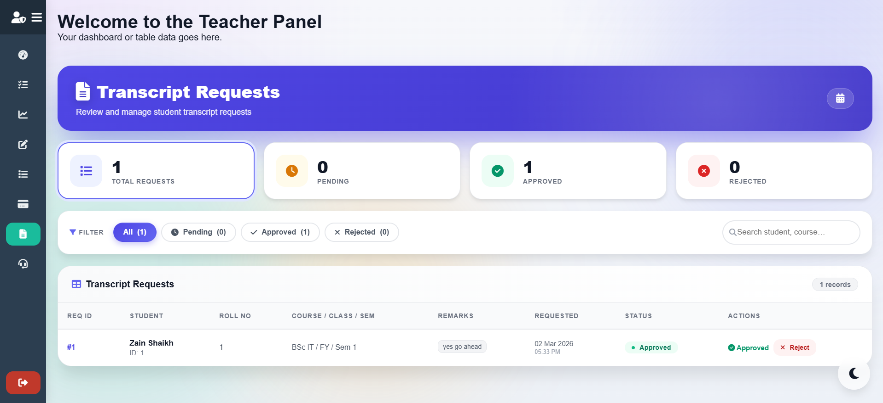

· Successful Execution of Core Functionalities:
All major features such as user login, attendance marking, report generation, and dashboard analytics performed as expected without critical errors.
· Accuracy of Data Processing:
Attendance data was correctly stored, retrieved, and displayed. Calculations such as attendance percentage and summaries were accurate.
· Validation and Error Handling:
The system effectively handled invalid inputs, such as incorrect login credentials and incomplete form submissions, by displaying appropriate error messages.
· Performance Evaluation:
The system demonstrated stable performance under normal usage conditions, with quick response times for data retrieval and processing.
· User Interface Behavior:
All pages were responsive and functioned correctly across different devices and screen sizes. Navigation between modules was smooth and intuitive.
· Security Verification:
Role-based access control was successfully enforced, ensuring that users could only access authorized features.
· Bug Identification and Resolution:
Minor issues identified during testing were resolved, and necessary improvements were implemented to enhance system stability.
The test reports confirm that the system meets the functional and non-functional requirements specified during the design phase.
Overall, the Attendance Management System has been tested thoroughly and is found to be reliable, efficient, and ready for deployment in a real-world academic environment.

6.2 User Documentation:-
User Documentation provides a clear and structured guide for users to understand and effectively use the Attendance Management System. It ensures that all types of users, including students, teachers, and administrators, can easily navigate the system and perform their respective tasks without confusion.
The system is designed with a user-friendly interface, making it simple for users with basic computer knowledge to operate the application. The following guidelines describe how different users interact with the system:
· Login Process:
Users must enter valid credentials such as username, email, or mobile number along with a password to access the system. Based on their role (Student, Teacher, Admin), they are redirected to the respective dashboard.
· Student Module:
Students can view their attendance records, attendance percentage, and subject-wise details. They can also track their attendance performance and stay informed about their academic status.
· Teacher Module:
Teachers can select course, class, semester, and subject to mark attendance. They can view student lists, update attendance records, and generate reports based on filters.
· Admin Module:
Administrators have full control over the system. They can manage student and teacher records, create notices, monitor attendance reports, and configure system settings.
· Attendance Marking:
Teachers can mark attendance by selecting students and assigning status (Present, Absent, Leave). The system validates entries to prevent duplication and errors.
· Report Generation:
Users can generate attendance reports based on different parameters such as class, subject, and date range. Reports can be viewed and exported for further use.
· Navigation and Interface:
The system provides a clean and responsive interface with clear menus, buttons, and dashboards, ensuring easy navigation across all modules.
· Error Messages and Alerts:
The system displays appropriate messages for invalid inputs, missing data, or unsuccessful operations, helping users correct mistakes easily.
This user documentation ensures that all users can operate the system efficiently, reducing the need for external support and enhancing overall usability.
Overall, the Attendance Management System is designed to be intuitive, accessible, and easy to use, providing a seamless experience for all users.

CHAPTER 7: CONCLUSION
7.1 Conclusion:-
The Attendance Management System developed in this project successfully achieves its primary objective of automating the traditional attendance recording process. By replacing manual methods with a digital, web-based solution, the system significantly improves efficiency, accuracy, and accessibility of attendance data.
The application provides a comprehensive platform where teachers can easily mark attendance, students can monitor their attendance status, and administrators can manage records and generate reports effectively. The integration of modern technologies such as Python, Flask, and PostgreSQL ensures that the system is reliable, scalable, and secure.
The system minimizes human errors associated with manual attendance, such as duplicate entries or incorrect calculations, by implementing validation mechanisms and structured data handling. Additionally, real-time data availability and reporting features enhance transparency and support better decision-making for academic institutions.
The user-friendly interface, combined with responsive design and role-based access control, ensures that users can interact with the system efficiently without requiring advanced technical knowledge.
Overall, the project demonstrates a practical implementation of a real-world problem solution, showcasing strong concepts of web development, database management, and system design. The Attendance Management System stands as a reliable and efficient tool that can be deployed in educational institutions to streamline attendance management processes.

7.1.1 Significance of the System:-
The Attendance Management System holds significant importance in modern educational environments by transforming the way attendance is recorded, managed, and analyzed.
The system plays a vital role in reducing manual workload for teachers and administrative staff by automating repetitive tasks such as attendance marking, data storage, and report generation. This allows educators to focus more on teaching activities rather than administrative work.
The implementation of a centralized digital system ensures accurate and secure storage of attendance records, minimizing the risk of data loss or manipulation. It also enhances transparency, as students can directly access and monitor their attendance status.
The system supports real-time data access and analytics, enabling institutions to identify attendance trends, detect irregularities, and take timely actions. This contributes to improved academic performance and discipline among students.
Furthermore, the system’s scalable architecture allows it to be extended with additional features such as notification systems, mobile access, and integration with other academic tools, making it adaptable to future technological advancements.
In conclusion, the Attendance Management System is not only a technical solution but also a significant step towards digital transformation in educational institutions, promoting efficiency, reliability, and smarter decision-making.
7.2 Limitations of the System:-
Despite the successful implementation of the Attendance Management System, certain limitations exist that may affect its functionality under specific conditions. Identifying these limitations is important for understanding the scope of the system and planning future improvements.
The current system, while efficient and reliable, has the following limitations:
· Internet Dependency:
The system is web-based and requires a stable internet connection for access. In case of network failure, users may face difficulty in accessing or updating attendance data.
· Limited Offline Functionality:
The system does not support offline attendance marking. All operations must be performed online, which may not be feasible in low-connectivity environments.
· Basic Security Implementation:
Although authentication and session management are implemented, advanced security features such as multi-factor authentication and encryption at all levels are not fully integrated.
· Scalability Constraints:
The system is designed for small to medium-sized institutions. Handling very large datasets or high concurrent users may require further optimization and infrastructure upgrades.
· Dependency on Manual Input:
Attendance marking is still dependent on manual input by teachers, which may lead to human errors if not carefully managed.
· Limited Notification System:
The current system has limited notification capabilities and does not fully support automated alerts via SMS or email.
· Browser Compatibility Issues:
Although tested on major browsers, minor inconsistencies may occur on older or less commonly used browsers.
· Lack of Mobile Application:
The system is accessible through web browsers but does not have a dedicated mobile application, which could enhance accessibility and user experience.
These limitations highlight areas for improvement and provide direction for future enhancements to make the system more robust, secure, and scalable.

7.3 Future Scope of the Project:-
The Attendance Management System developed in this project provides a strong foundation for digital attendance tracking. However, there are several opportunities for future enhancements that can further improve its functionality, scalability, and user experience.
The following improvements can be considered in future versions of the system:
· Mobile Application Development:
A dedicated mobile application can be developed for Android and iOS platforms, allowing users to access the system more conveniently and enabling attendance marking on the go.
· Biometric and RFID Integration:
The system can be enhanced by integrating biometric devices or RFID technology for automatic attendance marking, reducing manual effort and improving accuracy.
· AI-Based Analytics:
Advanced analytics using Artificial Intelligence can be implemented to predict attendance trends, identify at-risk students, and provide intelligent insights for decision-making.
· Notification System:
Automated notifications through SMS, email, or mobile push notifications can be added to alert students and parents about attendance shortages or important updates.
· Cloud Deployment:
Hosting the system on cloud platforms such as AWS or Azure can improve scalability, availability, and performance for large institutions.
· Multi-Institution Support:
The system can be extended to support multiple institutions within a single platform, allowing centralized management of attendance data.
· Advanced Security Features:
Implementation of multi-factor authentication, data encryption, and role-based access enhancements can strengthen system security.
· Integration with Other Systems:
The system can be integrated with Learning Management Systems (LMS), payroll systems, and academic portals for seamless data sharing and automation.
· Real-Time Dashboard Enhancements:
Improved dashboards with live data visualization and interactive charts can provide deeper insights into attendance patterns.
These future enhancements will make the system more powerful, intelligent, and adaptable to modern educational requirements. The project has strong potential to evolve into a comprehensive academic management solution with advanced features and wider applicability.

REFERENCES:-
[1] Flask Documentation. (2024). Flask Web Framework. Retrieved from https://flask.palletsprojects.com/
[2] PostgreSQL Documentation. (2024). PostgreSQL Database System. Retrieved from https://www.postgresql.org/
[3] SQLAlchemy Documentation. (2024). SQLAlchemy ORM. Retrieved from https://docs.sqlalchemy.org/
[4] Bootstrap Documentation. (2024). Bootstrap 5 Framework. Retrieved from https://getbootstrap.com/
[5] Mozilla Developer Network. (2024). HTML, CSS, and JavaScript Documentation. Retrieved from https://developer.mozilla.org/
[6] Python Software Foundation. (2024). Python Programming Language. Retrieved from https://www.python.org/

